WAN Selection Arrangements
Version: 1.6.1 (following the consultation, it will be issued as 2.0)
Date: 25/06/2026
Author: DCC
Document control heading

Revision history
Revision date | Summary of changes | Changes marked | Version number
16/07/2025 | Initial Version | No | 0.1
18/07/2025 | Updated following internal review | Yes (changes will be accepted before sharing externally) | 0.2
23/07/2025 | Updated following review by the DESNZ | Yes | 0.3
25/07/2025 | Updated following review by the DESNZ | No | 0.4
03/09/2025 | Updated following the consultation response | Yes | 0.5
12/09/2025 | Issued version | No | 1.0
28/04/2026 | Updated with changes for NECH Release 2 | Yes | 1.1
21/05/2026 | Updated following internal review | Yes | 1.2
02/06/2026 | Updated following internal review and review by DESNZ | No | 1.3
11/06/2026 | Updated following review by DESNZ | Yes | 1.4
19/06/2026 | Updated following review by DESNZ | Yes | 1.5
22/06/2026 | Updated following review by DESNZ | Yes | 1.6
25/06/2026 | Changes accepted for the consultation | No | 1.6.1

Table of Contents
1. Introduction 3
2. Overview of WAN interfaces on VWCH 3
2.1. Virtual WAN Communications Hub 3
2.2. WAN Route Priority Configuration 4
2.3. WAN link state assessments 4
2.3.1. SM WAN interface link state assessment 4
2.3.2. VWAN interface link state assessment 5
2.4. WAN link state assessment 5
2.5. VWAN interface activation during install and commissioning (I&C) 6
2.6. Heartbeat functionality on VWCH 7
2.6.1. Heartbeat over the SM WAN interface 7
2.6.2. Heartbeat over the VWAN interface 7
Appendix A – VWCH parameters for WAN Selection Arrangements 9
Appendix B – WAN interface selection for No, Poor and Good 4G connectivity conditions 15
Appendix C – WAN Interface Switching Algorithm Overview 18

Introduction
This document is the Wide Area Network (WAN) Selection Arrangements established in accordance with one or more Versions of Smart Energy Code (SEC) Schedule 10 ‘Communications Hub Technical Specifications’ (CHTS) to set out the conditions used by Virtual WAN Communications Hubs (VWCHs) to determine the WAN communications route to connect to the DCC.
This document sets out the WAN selection arrangements applicable to VWCHs. It sets out how VWCHs operate when equipped with two WAN interfaces (a 4G Smart Metering Wide Area Network (SM WAN) interface and a Virtual WAN (VWAN) interface via the Virtual WAN Device (VWD)), and the criteria used to select the active WAN interface.
From a DCC User perspective only one VWCH WAN interface is active at any point in time. The VWCH regularly monitors a number of 4G and VWAN signal quality parameters, regardless of which WAN interface is active. These operational signal quality parameters have associated configurable thresholds and monitoring windows to regularly determine whether they are “good” or “bad”. These determinations are used as inputs into the VWCH switching logic, the output of which then determines whether each WAN interface is “available to use” or “unavailable to use”. This output is also subject to a WAN interface priority setting which determines which WAN interface to select in the event where both are “available to use”.
In this document, italicised terms represent the parameters used for WAN interface selection as set out in Appendix A.
Other capitalised terms in this document shall have the meaning set out in Appendix D, or otherwise in the SEC.

Overview of WAN interfaces on VWCH

Virtual WAN Communications Hub
VWCHs are equipped with two WAN interfaces:
- SM WAN interface: a standard 4G cellular-based WAN interface.
- VWAN interface: a secure communication interface that utilises a VWD and the consumer’s internet connection.
At any point in time, only one of these WAN interfaces shall be active for WAN communication with DCC Users. The selection of the active WAN interface is based on:
- WAN Route Priority configuration: determined by the WANRoutePriority parameter – see section 2.2 for more details.
- WAN interface state assessment: the viability (in terms of connectivity) of each WAN interface – see section 2.3 for more details.
- WAN interface selection - If the active WAN interface is not viable, the VWCH may initiate a switch to the other WAN interface - see section 2.4 for more details.

WAN Route Priority Configuration
The VWCH includes a configurable parameter, WANRoutePriority, which determines the WAN interface for operational use when both WAN interfaces have viable connectivity. The parameter takes one of the following values:
- 0: The SM WAN interface.
- 1: The VWAN interface.

WAN link state assessments
Each VWCH device performs periodic monitoring of its WAN interfaces to determine viability of connectivity.

SM WAN interface link state assessment
The VWCH applies a detection mechanism every minute across three operational parameters: cellular signal conditions; frequent disconnections; and data path activity. As set out in Appendix C, the SM WAN interface link state is classified as “not viable” if any of the following criteria are “not good”:
- Criterion 1 – Signal quality degradation:
The VWCH monitors RSRP and RSRQ across a period of time defined by the CellularSignalStrengthMonitoringInterval parameter. If both RSRP and RSRQ remain below their configured RSRPThreshold and RSRQThreshold for the entire duration of this interval, the criterion is determined as “not good”, else it is “good”.
- Criterion 2 – Frequent disconnections:
The VWCH monitors the number of cellular link disconnections across a period of time defined by the CellularDisconnectionEventMonitoringInterval parameter. If the disconnection count is greater than or equal to the CellularDisconnectionThreshold parameter, the criterion is determined as “not good”, else it is “good”.
- Criterion 3 – Insufficient connection availability and data path validation:
During a period of time defined by the CellularConnectionMonitorInterval parameter, the VWCH assesses both cellular connection availability and cellular data path activity.
The VWCH calculates the percentage of time for which the cellular connection remains active during the monitoring interval. If this connected-duration percentage falls below the CellularActiveConnectionPercentage parameter, the criterion is determined as “not good”, else it is “good”.
Where heartbeat functionality over the SM WAN interface (see section 2.6.1) is enabled, data path validation is performed as part of the same monitoring interval. In this case, if the ‘connected duration’ percentage is equal to or higher than the CellularActiveConnectionPercentage parameter, the VWCH checks for receipt of incoming data packets over the SM WAN interface following activation of the cellular data session. If no incoming packets are received, the criterion is determined as “not good”, else it is “good”.

The SM WAN interface is “viable” only where criteria 1, 2 and 3 have been “good” during the most recent CellularConnectionMonitorInterval, as illustrated in Appendix C.

VWAN interface link state assessment
The VWAN interface link is established over two distinct network connections:
- A ZigBee connection between the VWCH and the VWD; and
- An Internet Protocol (IP) based connection using the internet between the VWD and the DCC.
The VWCH periodically exchanges heartbeat messages with the DCC systems at a configurable interval to ensure end-to-end connectivity over the VWAN interface. See section 2.6.2 for more details.
The VWAN interface link state is considered to be “viable” at the end of VWANConnectionMonitorInterval, if the VWCH receives at least VWANHealthCheckMsgCount number of authenticated message(s) in aggregate from the DCC (from any of the Data Service Provider (DSP), DCC device manager (DM) or Virtual WAN Provider (VWP)) throughout the configured monitoring period (VWANConnectionMonitorInterval), as set out in Appendix A, else it is “not viable”.

WAN link state assessment
The VWCH evaluates the viability of both WAN interfaces every minute and determines which is the active WAN interface based on:
- The current WANRoutePriority; and
- The link state of each WAN interface as set out in section 2.3.
The decision logic is as follows:
WANRoutePriority | SM WAN interface link state | VWAN interface link state | Active WAN interface selected
Cellular | Viable | Viable | SM WAN
Cellular | Viable | Not Viable | SM WAN
Cellular | Not Viable | Viable | VWAN
Cellular | Not Viable | Not Viable | Unchanged
VWAN | Viable | Viable | VWAN
VWAN | Viable | Not Viable | SM WAN
VWAN | Not Viable | Viable | VWAN
VWAN | Not Viable | Not Viable | Unchanged

Where a switch (change) in the active WAN Interface link occurs:
- A WAN route switch Alert is sent by the VWCH to the DCC device manager using the new active WAN interface. This Alert is not visible to DCC Users.
- If any Response or Alert is pending in the VWCH’s WAN outgoing queue at the time of the switch, the VWCH continues the remaining retry attempts using the new WAN interface route.
- Following the switch, incoming messages to the VWCH are accepted only via the new active WAN interface route.
- If a firmware download is in progress at the time of switching, the VWCH shall abort the download and sends a firmware download status Alert to the DCC device manager. The DCC device manager shall restart the firmware download once the download process has failed.
- Heartbeat monitoring: The VWCH sends periodic lightweight heartbeat messages to the DCC, which are acknowledged in return. This monitoring continues independently over both the SM WAN and VWAN interfaces, irrespective of the active WAN route. See section 2.6 for more details.

An exception to this decision logic applies when Inter-PAN is used, as set out in section 2.5.

VWAN interface activation during install and commissioning (I&C)
When VWAN is activated during I&C via the VWD Inter-PAN join (as set out in GBCS version 4.4 or later), the VWCH shall temporarily use the VWAN interface as the active WAN interface route for remote communication, irrespective of SM WAN interface viability, as set out below.
If the VWCH has already birthed (VWCH CHF is Commissioned) at a site with good or poor cellular signal using the SM WAN interface, it shall send a WAN route switch Alert (not visible to DCC Users) indicating the change of the active WAN interface via VWAN interface.
Based on the VWCH parameters defined in Appendix A, the earliest transition from the VWAN interface to the SM WAN interface shall occur after the CellularConnectionMonitorInterval. During this period, installation activities will be completed using the VWAN prior to assessment of whether to switch to the SM WAN interface in accordance with the WAN interface link state assessment described in section 2.4.

Heartbeat functionality on VWCH

Heartbeat over the SM WAN interface
4G Communications Hubs (CH) that operate solely over the SM WAN interface include a configurable heartbeat capability. This enables the CH to periodically transmit lightweight messages to the DCC, for which acknowledgements are received. The receipt of such acknowledgements is used by the CH to confirm that the cellular data path is operational over the SM WAN interface.
The heartbeat functionality over the SM WAN interface is used as part of criterion 3 of the SM WAN interface link state assessment.

Heartbeat over the VWAN interface
The VWCH shall provide equivalent heartbeat functionality over the VWAN interface. The VWCH shall transmit lightweight heartbeat messages periodically to the DCC, with corresponding acknowledgements received in return. The receipt of these acknowledgements shall be used to confirm end-to-end data path is operational over the VWAN interface, comprising both the ZigBee connection and IP based internet connection.
Heartbeat monitoring over the VWAN interface shall continue independently of the active WAN interface, ensuring that the VWAN link is maintained and available for use when required.
The frequency of heartbeat messages over the VWAN interface shall be configurable using CellularRouteVWPHealthCheckInterval (when SM WAN is the active WAN interface) and VWANRouteVWPHealthCheckInterval (when VWAN is the active WAN interface), as defined in Appendix A.
The VWCH shall support adaptive adjustment of heartbeat frequency based on sustained link stability, as follows:
- Where the SM WAN interface link state remains “viable” for CellularConnectionMonitoringCycleForAdaptiveHealthCheck consecutive monitoring cycles, the VWCH shall increase (double) the CellularRouteVWPHealthCheckInterval, thereby reducing the heartbeat frequency. Where the SM WAN interface link state subsequently deteriorates, the VWCH shall revert the interval to the default value defined in Appendix A.

- Where the VWAN interface link state remains “viable” for VWANConnectionMonitoringCycleForAdaptiveHealthCheck consecutive monitoring cycles, the VWCH shall increase (double) the VWANRouteVWPHealthCheckInterval, thereby reducing the heartbeat frequency. Where the VWAN interface link state subsequently deteriorates, the VWCH shall revert the interval to the default value defined in Appendix A.
- The adjusted heartbeat interval shall not exceed VWANConnectionMonitorInterval ÷ (VWANHealthCheckMsgCount + 1), ensuring that the minimum required number of authenticated messages are received within the monitoring interval.
The heartbeat functionality over the VWAN interface shall be used for VWAN interface link-state assessment.

Appendix A – VWCH parameters for WAN Selection Arrangements
The following VWCH parameters apply to VWCH and:
- shall not be changed by VWCH firmware updates; and
- persist through power cycles.

VWCH Parameter | Value | Allowed range | Significance | Justification for chosen Value | Impact on WAN interface switching behaviour
WANRoutePriority | 0 | [0, 1] | The VWCH uses this to set the priority WAN interface. | SM WAN is the priority route for all VWCHs considering VWAN activation is an option. | WANRoutePriority affects the selection of the active WAN interface, as outlined in Section 2.1
CellularActiveConnectionPercentage | 70% | [10, 100] % | Specifies the minimum percentage of time within the CellularConnectionMonitorInterval for which the cellular data connection shall remain active for the link state to be evaluated as “good” in accordance with criterion 3 defined in section 2.3.1. | 70% of 360 minutes of CellularConnectionMonitorInterval evaluates to 4 hours 12 minutes.  This duration exceeds the SM WAN interface self-recovery period (up to 4 hours), thereby allowing sufficient time for recovery prior to the link-state assessment.  Note : The SM WAN interface self-recovery capability is an existing feature of 4G CHs implemented to support performance requirements for connectivity over the SM WAN interface.  As part of this self-recovery mechanism, where no data packets are received over the SM WAN interface within a 2-hour period (heartbeat over SM WAN is used for this – see section 2.6.1), an additional recovery period of up to 2 hours (i.e. a maximum of 4 hours in total) shall be allowed to enable restoration of the cellular link, including re-attachment to the 4G network. | The evaluation time for criterion 3 is dependent on the configured values of CellularActiveConnectionPercentage and CellularConnectionMonitorInterval.  Reducing these values may enable faster switching behaviour, provided that criteria 1 and 2 thresholds are also set appropriately.
CellularConnectionMonitorInterval | 360 minutes | [1, 65535] minute(s) | Specifies the interval over which the VWCH shall monitor the cellular connection to determine the SM WAN link state in accordance with criterion 3 defined in section 2.3.1.  This CellularConnectionMonitorInterval must be greater than CellularDisconnectionEventMonitoringInterval and CellularSignalStrengthMonitoringInterval.
VWANConnectionMonitorInterval | 120 minutes | [1, 65535] minute(s) | The interval over which the VWAN connection is monitored to detect the VWAN link state. | As the minimum heartbeat interval for VWAN (CellularRouteVWPHealthCheckInterval or VWANRouteVWPHealthCheckInterval) is set to 30 minutes, at least 1 (VWANHealthCheckMsgCount) authenticated message is expected to be received within a 120-minute monitoring interval (VWANConnectionMonitorInterval).  A default heartbeat interval of 30 minutes is considered an appropriate initial configuration.  As part of the adaptive heartbeat mechanism, the VWCH shall adjust the heartbeat interval based on sustained WAN link stability.  Where the SM WAN interface link state remains “viable” for 3 (CellularConnectionMonitoringCycleForAdaptiveHealthCheck) consecutive monitoring cycles, the VWCH shall increase the CellularRouteVWPHealthCheckInterval (by doubling the interval from 30 minutes to 60 minutes), thereby reducing the frequency of heartbeat messages.  A similar approach shall apply when the VWAN interface is the active WAN route. Where the VWAN interface link state remains “viable” for 3 (VWANConnectionMonitoringCycleForAdaptiveHealthCheck) consecutive monitoring cycles, the VWCH shall increase the VWANRouteVWPHealthCheckInterval (by doubling the interval), thereby reducing the heartbeat frequency.  See section 2.6.2 for detail. | The VWAN link-state assessment relies on the VWANConnectionMonitorInterval and VWANHealthCheckMsgCount parameters. Increasing the VWANConnectionMonitorInterval facilitates adaptive heartbeat optimisation and does not impact the switching logic between WAN routes.
VWANHealthCheckMsgCount | 1 | [1, 65535] | Specifies the minimum number of incoming authenticated messages that must be received during the VWANConnectionMonitorInterval for the VWAN interface link to be considered “viable” as set out in section 2.3.2.
CellularRouteVWPHealthCheckInterval | 30 minutes | [1, 65535] minute(s) | The interval between VWAN heartbeat messages, which applies when the SM WAN interface is the active WAN interface and no inbound messages have been received over VWAN during that period.  Note: When SM WAN interface is active, VWAN heartbeat messages continue to be exchanged to maintain the VWAN link and enable timely change of WAN interface. |  | These intervals shall not exceed VWANConnectionMonitorInterval ÷ (VWANHealthCheckMsgCount + 1).  Where the interval duration is increased, the VWANConnectionMonitorInterval shall be increased accordingly to ensure that at least VWANHealthCheckMsgCount authenticated messages are received within the monitoring interval.
VWANRouteVWPHealthCheckInterval | 30 minutes | [1, 65535] minute(s) | The interval between VWAN heartbeat messages, which applies when the VWAN interface is the active WAN interface and no inbound messages have been received over VWAN during that period  Note: VWAN heartbeat messages continue to be exchanged to maintain the VWAN link.
CellularSignalStrengthMonitoringInterval | 300 minutes | [1, 65535] minute(s) | The interval over which the VWCH shall monitor cellular signal strength (both RSRP and RSRQ) to evaluate the cellular link state in accordance with criterion 1 defined in section 2.3.1.  Lower cellular signal strength may still support a good data path. This monitoring interval ensures that the VWCH does not consistently operate below the configured signal threshold. Hence, CellularSignalStrengthMonitoringInterval is set little longer to avoid any temporary environmental conditions that may lower the signal strength. | Cellular signal strength and quality at a site may be affected by temporary environmental factors or obstructions.  Monitoring sustained low signal conditions over a period of 300 minutes (5 hours) is considered an appropriate initial configuration to avoid transient fluctuations influencing the SM WAN interface link state assessment. | The evaluation time for criterion 1 is dependent on the configured values of CellularSignalStrengthMonitoringInterval.  Reducing these values may enable faster switching behaviour but may result to false positive due to temporary obstruction causing the signal strength.
RSRPThreshold | -118 dBm | [-119, -44] dBm | The threshold value used by the VWCH to compare measured RSRP for cellular link-state evaluation. | The RSRP and RSRQ threshold values defined for the 4G CH cell-selection and reselection process have been adopted in VWCH as the baseline configuration for criterion 1. | If these values are too high (lower negative number), VWCH may switch to VWAN even though steady SM WAN connection is available.  If these values are too low (higher negative number), VWCH may wait longer to switch.
RSRQThreshold | -18 dB | [-20, 0] dB | The threshold value used by the VWCH to compare measured RSRQ for cellular link-state evaluation.
CellularDisconnectionEventMonitoringInterval | 60 minutes | [1, 65535] minute(s) | The interval over which VWCH monitors and counts cellular link disconnection events for the purpose of evaluating link stability as set out in criterion 2 in section 2.3.1. | A value of 5 disconnections (CellularDisconnectionThreshold) within a 60-minute CellularDisconnectionEventMonitoringInterval is considered an appropriate initial configuration.  These values may be subject to revision based on operational data observed in poor WAN sites, in accordance with agreed WANSA governance. | The evaluation time for criterion 2 is dependent on the configured values of CellularDisconnectionEventMonitoringInterval and CellularDisconnectionThreshold.  These values are informed by expected frequent disconnections at poor WAN sites.
CellularDisconnectionThreshold | 5 | [1, 65535] | Specifies the maximum number of cellular disconnection events permitted within the CellularDisconnectionEventMonitoringInterval as set out in criterion 2 in section 2.3.1
CellularConnectionMonitoringCycleForAdaptiveHealthCheck | 3 | [1, 65535] | Specifies the number of consecutive monitoring cycles for which the cellular interface link state must remain good before the CellularRouteVWPHealthCheckInterval is adjusted to support adaptive heartbeat logic over the VWAN interface. | A value of 3 consecutive monitoring cycles for reducing the heartbeat frequency considered an appropriate initial configuration.  Where a higher value is configured, the VWCH shall require a longer duration before adjusting the heartbeat interval. | This parameter does not impact switching behaviour.
VWANConnectionMonitoringCycleForAdaptiveHealthCheck | 3 | [1, 65535] | Specifies the number of consecutive monitoring cycles for which the VWAN interface link state must remain good before the VWANRouteVWPHealthCheckInterval is adjusted to support adaptive heartbeat logic over the VWAN interface. |  | This parameter does not impact switching behaviour.

Once the WAN Selection Arrangements have demonstrated sufficient evidence of reliability, the DCC may update these parameters for commissioned VWCHs, to improve operational efficiency, in accordance with WANSA governance. Updates shall be delivered using DCC-generated commands to the VWCH over the active WAN interface.

Appendix B – WAN interface selection for No, Poor and Good 4G connectivity conditions
This section is for information only.
Scenario | 4G connectivity condition | Notes
1 – Install & Commission | Any (No, Poor or Good) | The Inter-PAN VWAN activation (section 2.5) can be performed without utilisation of the cellular SM WAN route. As a result, VWAN may be activated at any site irrespective of 4G signal quality or cellular connectivity issues.  Where VWAN is activated via the Inter-PAN method following issues encountered during I&C due to poor cellular conditions, the VWCH shall ensure that any messages pending transmission over the SM WAN interface are transmitted via the VWAN interface following the WAN route switch. This shall enable the remaining I&C activities to continue while the VWCH is operating over the VWAN interface.  The VWCH shall remain on the VWAN interface for a minimum duration of the CellularConnectionMonitorInterval as per the parameters in Appendix A, after which WAN link assessment as per section 2.3 determines which WAN interface is active.
2 – Post Commissioning | Good 4G | When switching from the VWAN interface back to the SM WAN interface, the VWCH shall evaluate all three cellular link-state criteria as illustrated in Figure 1.  As a result, once the VWAN interface becomes active the VWCH shall not switch to SM WAN interface earlier than CellularActiveConnectionPercentage of the CellularConnectionMonitorInterval (which equates to 4 hours and 12 minutes based on 70% and 300 minutes) as per the parameters in Appendix A, provided that criterion 1 (signal degradation) and criterion 2 (frequent disconnection) remain “good” in that duration, as defined in Section 2.3.1.  In good 4G situations, the SM WAN interface will become active after this duration.
2 – Post Commissioning | Poor 4G | Lower or fluctuating 4G signals may still support a viable data connection over cellular, and the cellular modem is designed to establish and re-establish connectivity wherever possible.  Hence, the combined assessment of  - sustained low signal strength;  - frequency of cellular disconnections; and  - connection duration with validation of data packet receipt (a measure of the ability to send and receive messages)  ensures cellular link quality is evaluated holistically to determine whether it is suitable for smart metering communications.  As set out in section 2.3.1, if any one of the following criteria:  - Criterion 1: cellular signal degradation  - Criterion 2: frequent disconnections  - Criterion 3: Insufficient connection availability and data path validation  are “not good” and the VWAN link is “good”, the VWCH shall switch to the VWAN interface as shown in Figure 2 in Appendix C.  In poor WAN scenarios, at least one of these criteria will be “not good”.  Once the VWAN interface becomes active the VWCH shall not switch to cellular SM WAN interface earlier than CellularActiveConnectionPercentage of the CellularConnectionMonitorInterval (which equates to 4 hours and 12 minutes based on 70% and 300 minutes), provided that criterion 1 (signal degradation) and criterion 2 (frequent disconnection) remain “good” in that duration, as defined in section 2.3.1.  In poor 4G scenarios, it is unlikely that these criteria remain “good” for such durations and as such the VWAN interface will remain active for longer durations.
2 – Post Commissioning | No 4G | Once the VWAN interface becomes active the VWCH shall not switch to SM WAN interface (if available) earlier than CellularActiveConnectionPercentage of the CellularConnectionMonitorInterval (which equates to 4 hours and 12 minutes based on 70% and 300 minutes), provided that criterion 1 (signal degradation) and criterion 2 (frequent disconnection) remain “good” in that duration, as defined in section 2.3.1.  In no 4G situations, the SM WAN interface link state assessment (criterion 1, 2 or 3) cannot be evaluated as “good”. As a result, the VWAN interface shall remain the active WAN route.

Appendix C – WAN Interface Switching Algorithm Overview
Figure 1: SM WAN link assessment steps while VWAN interface is active (and SM WAN is the priority route)
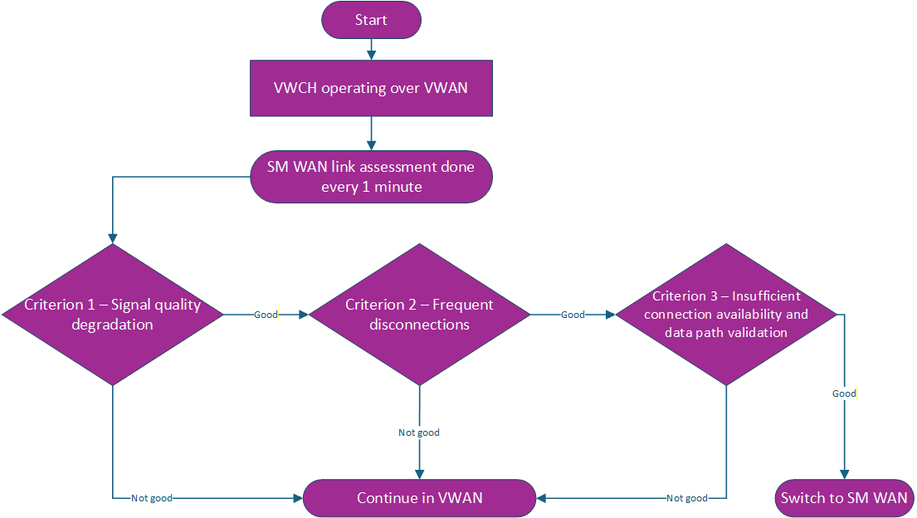

Figure 2: SM WAN and VWAN interface assessment steps (and SM WAN is the priority route)
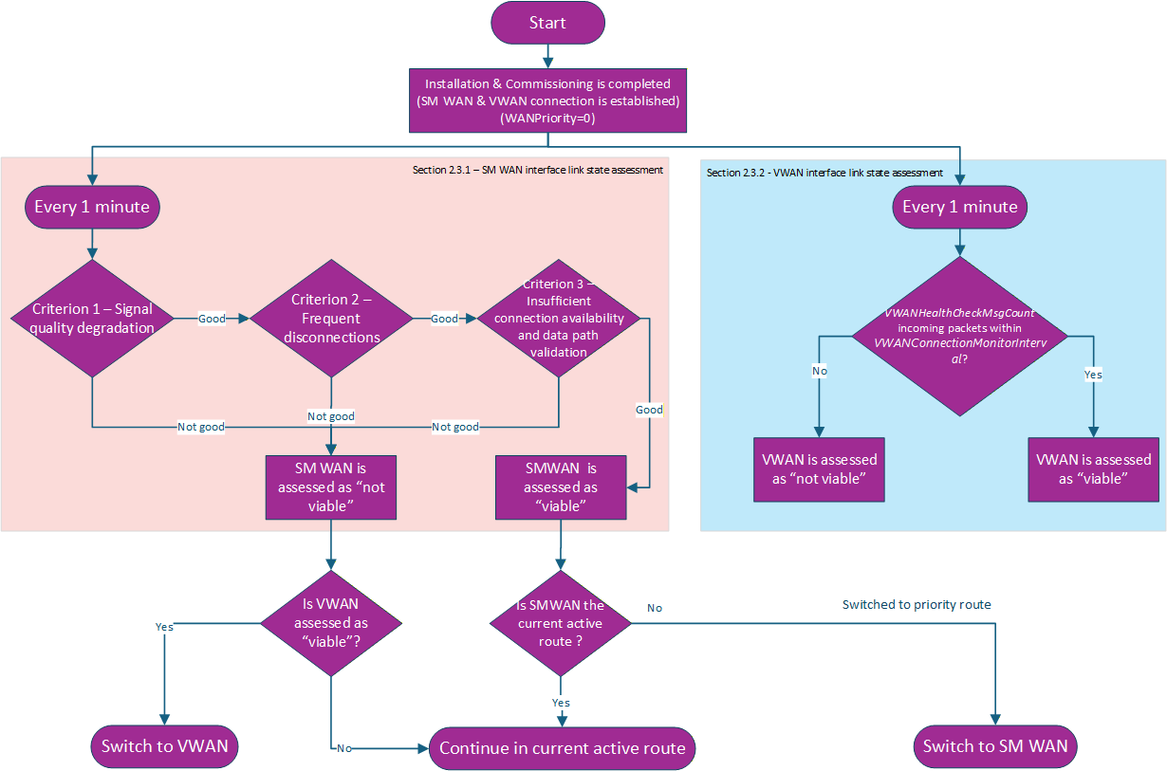
NB The SM WAN interface is “viable” only where criteria 1, 2 and 3 have been “good” during the most recent CellularConnectionMonitorInterval.

Appendix D – Definitions
Term | Meaning
Received Signal Strength Indicator (RSSI) | means, in relation to a VWCH at a specific time, the measured power level of the radio signal received by the VWCH at that time, expressed in decibel-milliwatts (dBm).
Reference Signal Received Power (RSRP) | means, in relation to a VWCH at a specific time, the average power of the cellular signal received by the VWCH at that time, expressed in decibel-milliwatts (dBm).
Reference Signal Received Quality (RSRQ) | means, in relation to a VWCH at a specific time, the ratio between (i) the product of RSRP and the number of Resource Blocks allocated to the VWCH and (ii) RSSI at that time, expressed in decibel (dB).
Resource Block | means, a unit of radio resource allocated to the VWCH.
WAN Interface | has the meaning given to that term in the Communications Hub Technical Specification

