|  |  |
| --- | --- |
| **Version:** | **1.0 – draft for customer consultation** |
| **Date:** | **15/5/2020** |
| **Author:** | **DCC Strategy & Business Planning** |
| **Classification:** | **DCC Public** |

# DRAFT

# Business and Development Plan 2021-22 – 2025-26

Contents

1. Introduction 3

2. Chairman’s foreword 3

3. Executive summary 4

4. Who are we and what we do 5

5. Market context 6

6. Our priorities and plans 6

6.1. Smart Meters - Support the successful smart meter rollout across Great Britain by maintaining and improving the DCC’S secure data network and our complementary services. 9

6.1.1. Ensuring reliability and stability 9

6.1.2. Service improvement plan 9

6.1.3. Enduring plan 10

6.2. Dual-Band Communications Hubs 10

6.3. Great Britain Companion Specification (GBCS) 10

6.4. SMETS1 migration programme 11

6.4.1. Final Operating Capability 12

6.4.2. Performance 12

6.4.3. Post migration 13

6.4.4. Working with our customers 14

6.5. Network Utilisation and capacity planning 14

6.5.1. Volume of installed meters 14

6.5.2. Network coverage 15

6.5.3. Historic incident levels 16

6.5.4. Alert incident types – volume management 16

6.5.5. Working to resolve issues 17

6.5.6. Testing Capacity 17

6.5.7. Forecasting of core communication and connectivity capacity 17

6.5.8. Impact of COVID-19 18

6.5.9. Forecast of SMETS2 and service volume requests 18

6.5.10. Service Centre Capacity 19

6.6. Enduring Change of Supplier (ECoS) 20

6.6.1. Overview 20

6.6.2. Timescales 20

6.7. DNO Transformation Programme 20

6.7.1. Benefits 20

6.8. Smart Energy Code (SEC) System Releases 21

In-Life Change Programme 21

6.8.1. Benefits 22

6.8.2. Forward look 22

6.8.3. Improving oversight and governance  22

6.9. Standardised customer analytics reporting 22

6.10. Mandated Programmes - Successfully deliver the programmes over and above smart metering that are mandated by Government or the regulator in a cost-efficient and transparent way to enable the transformation of the energy system for wider customer and social benefit. 24

Reforming the retail market 24

6.11. Faster switching 24

6.11.1. Overview 24

6.11.2. Milestones 24

6.11.3. Address data 25

6.11.4. Technology roadmap 25

6.11.5. Working in partnership 25

6.12. Market-Wide Half Hourly Settlement (MHHS) 25

6.12.1. Overview 26

6.12.2. Initial steps 26

6.12.3. Timescales 26

6.12.4. Proposed milestones 26

6.12.5. Electric Vehicle - Smart Charging 27

6.13. System Enhancement - Ensure that the DCC network remains fit for purpose and is able to respond to change and future demands by adopting new technologies and seeking innovative ways of working with our service providers to ensure ongoing improvements and value for money for our customers. 28

6.13.1. Network Evolution - Overview and benefits 28

6.13.2. Timescales 29

6.13.3. Elective Communication Services 30

6.13.4. DCC Operations - Operating live services 30

6.13.5. Operational customer relationship management 31

6.13.6. Improving knowledge 31

6.13.7. Improving ways of working 31

6.14. Security 31

6.14.1. Information management 31

6.14.2. Threat-led defence 31

6.14.3. Zero-trust approach 32

6.14.4. Demonstrable compliance 32

6.15. Re-Use - Identify and promote ways to re-use the DCC secure network with the objective of reducing charges for our customers, enabling the delivery of social good and supporting the net zero carbon objective. 32

6.15.1. Overview 32

6.15.2. Helping our customers innovate 33

6.15.3. Mandated growth to deliver government priorities 33

6.15.4. Wider innovation 34

6.16. Culture and Capability - Ensure DCC remains fit for purpose, delivers value for money with an agile and flexible workforce that can support the needs of our customers. 36

Preparing for the future 36

6.16.1. DCC Transformation Programme 36

6.16.2. Improving systems, culture and capability 36

6.17. Culture 36

6.17.1. Capability 36

6.18. Customer engagement 37

6.18.1. Short term focus of engagement 37

6.18.2. Collaboration 37

6.18.3. Transparency 38

6.18.4. Timing 38

6.18.5. Responding to feedback 38

6.18.6. Longer-term focus for engagement 38

6.19. Driving costs down and providing value for money 39

6.19.1. Controlling supplier costs 39

6.20. Cost transformation 39

6.20.1. Smart Savings Programme 39

6.20.2. RY 20/21 highlights 39

6.21. DCC price control framework 39

6.22. Operational Performance Regime 40

6.23. Assessment criteria for business development objectives 40

7. Financial Summary 41

# Introduction

Customer involvement has been crucial to the drafting of this Business and Development plan. Customers worked with us, from February through to March 2021, via webinars and workshops and provided us with insights, knowledge and views about the issues that concern them and how we should prioritise the many activities that we may be obliged to deliver.

We have now produced this draft Business & Development Plan and welcome any final comments customers may have prior to its final publication in July 2021.

Please visit <https://www.smartdcc.co.uk/smart-future/draft-business-and-development-plan/> to submit any feedback by xx 2021

# Chairman’s foreword

To follow in the final publication

# Executive summary

DCC’s national network has a critical role to play in helping the country to hit its net-zero carbon target and underpins the roll-out of smart metering across Great Britain. Delivering this core service for our customers remains our priority.

Over the last year we have worked hard to improve our performance, with new initiatives such as our ‘right first time’ commitment to enrol smart meters at the first attempt, and we will look to sustain and improve the rate of roll-out.

At the same time, we continue to support the energy industry in delivering vital programmes, such as faster switching, and we will work with our customers on longer-term plans for re-use of our unique and highly secure network, while maintaining our rigorous control of costs.

2020 brought a challenge of a type not witnessed in living memory with the global COVID-19 pandemic. But thanks to the adaptability and resilience of our people, DCC and our customers kept the nation’s smart meter roll-out on track.

We quickly introduced new processes to shift most of our staff to working from home, while keeping a small number of key people on-site in our technical operations centre and test labs. Installations of second-generation smart meters ground to a halt at the beginning of lockdown, but then rebounded very strongly.

Throughout the year, we were still able to grow the DCC network and remotely migrated over 3.7 million first-generation smart meters, including 1.75 million previously ‘dormant’ meters which have had their smart capability restored. Our migration performance remains strong, with over 99% of migrations delivered ‘right first time’ every week. Migration of the final cohort of first-generation meters is still at a very early stage. However, we do expect to complete the programme within the timeframe set down by Ofgem.

We continue to take steps to improve our operational reliability and stability, particularly in our North region where we have launched a service improvement plan to resolve key performance issues. These actions will shift the focus from purely percentage performance measurements to improving overall business outcomes for our customers.

Our Network Evolution Programme, which explores how new processes, systems and technologies can improve the live service, is in the early phases of development. We are consulting with the industry on delivering future data services, we are running procurement for the next generation of communications hubs and we plan to begin automation of testing in spring 2022.

We recognise the that we need to improve the customer experience of Distribution Network Operators (DNOs) as a core customer group. During the year we launched our DNO Transformation Programme which will establish accurate, automated dashboard reporting of key performance indicators and develop data insight to enable improvement. Full dashboards will be available by September.

SEC Modifications are industry-wide requests for changes to our services and we successfully delivered two SEC System Releases in 2020 on time and within budget. We have improved our process and system designs to give better visibility of progress throughout the release cycle. We recognise that we must be more proactive with service providers in solution design. To achieve this, we are creating a new role of Head of Design.

Over the past year, we have invested significantly in analytics reporting and monitoring to identify the causes of performance failings across the DCC ecosystem. We are working with all our customers to identify the key metrics for each of the business processes that they initiate. We will then create standardised reporting packs, with their input, which will include benchmarked performance measures. We expect the new packs to be available from this summer.

We are working with Ofgem to make it possible for consumers to switch energy suppliers much more quickly, within the next working day. This involves creation of the new Central Switching Service (CSS). In October 2020 the programme underwent a managed re-plan requested by the industry because of the COVID-19 pandemic. As a result, the ‘go-live’ date for the new service has been rescheduled to the summer of 2022. But the switching programme is on track and several key milestones have been achieved.

We continue to work with source data providers to improve the quality of address data for domestic consumers, something which is essential to improve the switching process. We have also commissioned a roadmap analysis of the changes and innovations likely to affect switching in future years, ensuring that the system can remain agile and meet the needs of our customers for many years to come.

Effective engagement is essential if we are to make the transition to faster, more reliable switching. We have hosted two ‘Switching Summits’ with the industry, held entirely online, and organised several shorter, focused online briefing sessions.

The introduction of Market-Wide Half Hourly Settlement (MHHS), allowing access to half-hourly data, will increase competition in the energy market and benefit consumers. We have been engaging with Ofgem on how to implement this. A solution has been agreed with costs and we expect to start testing in January 2023, ahead of final implementation the following November.

We have taken several key steps to ensure that the operation of our live service can handle the many challenges that we face. We have negotiated a cost reduction on our Service Centre contract over a two-year extension and secured a new, more flexible resourcing model. We are focusing our problem management more on pro-active investigations and we have upgraded our forecasting capability. We are putting customers first by aligning our service operations teams more closely with different customer types so that they can gain greater knowledge and understanding of them.

The security of our network is without parallel. But we must evolve constantly to meet emerging threats. So we are introducing a new business-wide policy to ensure consistent handling and storage of data; adopting a threat-led defence approach which more accurately anticipates likely attacks; taking a ‘zero-trust’ position on the authentication of people and documents; and using more practical compliance techniques for risk assessment of our supply chain.

Re-use of the DCC Network for new purposes has the potential to bring enormous benefits to the energy industry and consumers. We are concentrating our work here in the areas which reflect the priorities of the industry and our other stakeholders.

Our state-of-the-art test labs are helping to develop new products for existing customers and demonstrate additional capabilities within the smart meter system, such as load control. We are working with governmentdepartments to deliver key policy priorities, including electric vehicle (EV) charging infrastructure. We are redesigning the ECS process - which allows customers to develop new messaging services on our platform - to make it more agile, cost effective and commercially appealing.

The re-use our network to develop new wholesale products in new markets, such as water metering and digital wellbeing, is an attractive proposition. However, re-use must be achieved in the right way, without detriment to our core services and to the benefit of our customers and other stakeholders. So we will be restricting ourselves to light touch activities in this area.

We are taking steps to transform the culture and capability of DCC. Our Business Accuracy and Finance Transformation programme, which is designed to improve our planning, forecasting and reporting, will come into effect this year. We have achieved greater control and centralisation of our IT resources, and we have invested new money in platforms to improve business accuracy and automate processes.

Above all, we want to deliver value for money for our customers. Since its launch three years ago our Smart Savings Programme has delivered £358 million in cashable savings. Cost saving targets continue to be factored into future years, committing us, in effect, to achieve a minimum cash saving target every year.

Getting our culture right is central to the long-term wellbeing of DCC. So we are taking time to assess our current culture, focusing on a review of the organisation’s values and behaviours to ensure that they are fully aligned to our purpose and strategy. This will empower our leaders and colleagues to make the right decisions for our business, our customers and our people.

Customer engagement is an area where we recognised that we needed to make some big improvements. Last year we set out a new approach to engagement called “Inform, Shape and Survey”. This involves being clear about the progress and costs of projects; sharing business cases with customers; and conducting surveys to gauge industry views.

This year we have made good progress, despite the challenges posed by COVID-19. But there is more to be done. Our online customer portal was not fit for purpose, so we are looking at a better solution. We are overhauling our formal quarterly finance updates to share more detail on forecast spend, costs and programme updates. We are also looking at the timing of our engagement with customers to make sure that they are given enough time to shape our plans.

Effective engagement is about more than sharing information and asking customers for their thoughts. It is also about acting on their feedback. That is why we have made the improvement of our responses a key priority, so that customers can trace their feedback against activities as they develop, know when they can expect decisions and understand our rationale.

Partnership with our customers is at the heart of the DCC approach and underpins this Business & Development Plan. It is the key ingredient which will help the industry to deliver benefits for millions of consumers and create the clean energy system of the future.

# Who are we and what we do

DCC provides the digital backbone of Great Britain's smart energy infrastructure.

The DCC is a private company licensed by the Government and regulated by Ofgem to connect smart meters in homes and businesses across the country to a single secure, digital network. The DCC’s digital network will help enable Britain to hit its 2050 net zero carbon target for example by supporting the decarbonisation of energy generation and the management of energy demand across the system.

We support the roll-out of second-generation (SMETS2) smart meters, as well as the migration of existing first-generation (SMETS1) meters onto our network.

We are also working with the energy regulator, Ofgem, to deliver a faster, simpler Central Switching Service for energy consumers. We have recently been commissioned to play a major role in the delivery of domestic half-hourly settlement, building on the foundation of the smart meter roll-out.

With millions of smart meters already connected to our network, we’re helping people to save hundreds of thousands of tonnes in carbon emissions every year. We're enabling our customers to shape the energy market of tomorrow, empowering consumers and maximising the use of renewable power.

**[boxed out with graphic of how our network operates] Secure national infrastructure**

Our network comprises the mobile phone network in the south and central parts of Great Britain, and a dedicated radio network in the north. Taken together at scale, this network provides greater reach than mobile phones, digital terrestrial TV and superfast broadband combined, and will bring the benefits of smart metering to more than 30 million homes and small businesses.

We operate to national and international security standards endorsed by the National Cyber Security Centre (NCSC). The information that travels across our network is encrypted so that it is readable only by the consumer’s own energy supplier, a level of security far higher than standard home broadband.

# Market context

At DCC, we believe in making Britain more connected, so we can all lead smarter, greener lives. We believe this purpose complements Ofgem’s objectives of protecting the interests of consumers, facilitating decarbonisation at the lowest cost, and enabling competition and innovation.

Our core business remains the operation of the smart meter communications network, focusing on increasing the efficiency, quality and stability of our platform and working with our customers to enhance the service we offer in response to their needs, whilst delivering the required security controls protecting our national infrastructure. We are also delighted to be partnering with Ofgem in the delivery of faster, more reliable switching, and supporting the delivery of market-wide Half Hourly Settlement – both programmes are vital to delivering better outcomes for consumers.

In addition, this nationwide infrastructure, already built, secure and in operation, can play a key role in helping the UK reach its target of Net Zero by 2050. The superior reach, connectivity and security of our network makes us a unique asset that can be reused, leveraged by Government and Regulators to implement policy interventions that aid the energy transition and deliver public benefits and wider social value. As such DCC is actively monitoring developments in technology, policy, and markets relevant to our business.

We welcome the Government’s recent Energy White Paper[1], *Powering our Net Zero Future*, which sets out the vision for a sustainable energy system that meets the needs of the Net Zero agenda and places consumers at its heart. We believe that DCC has a central role to play in supporting this vision. To achieve national decarbonisation, several transitions must run in parallel. Foremost among these are the decarbonisation of energy generation, and the electrification of sectors that are currently dependant on fossil fuels - such as transport and heat.

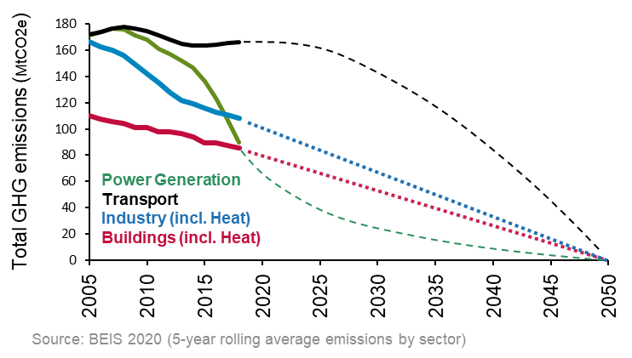

As a result of these transitions, energy systems will need to incorporate more intermittent supply (from renewables such as wind and solar), and also handle greater demand for electricity, and sharper *peaks* of demand (from the electrification of heat and transport). We will therefore need a smarter and more flexible energy system, managed down to local grid level, to help move demand away from the peaks (e.g. 5-7pm), to times where demand is lower anyway (e.g. overnight). Reducing this peak will deliver benefits through reduced curtailment of intermittent renewables, reduced need for generation / capacity and less network infrastructure reinforcement – thereby keeping costs lower for consumers.

Local communities have a key role to play in this by developing an integrated approach to managing energy demand in their areas by adopting smart energy systems that combine heating, power and transport solutions to bring significant reduction to emissions and as well as promoting local jobs and wellbeing.

The Energy White Paper highlights the critical role of smart metering in supporting this transition to Net Zero, by enabling:

* consumers to access innovative solutions such as time-of-use tariffs.
* using smart enabled flexibility services to avoid periods of high demand, benefiting the grid, and reducing running costs when deployed with storage and smart meters; and
* harnessing smart meter data to help DNOs to identify system constraints and direct their investment more efficiently, including where network reinforcement is required to support an increase in heat pumps or electric vehicles (EVs).

The smart metering network therefore has a pivotal role to play in supporting the delivery of government objectives, particularly given it conforms to the highest cyber security standards backed by the National Cyber Security Centre (NCSC).

In the following section we lay out the major trends that we see dominating the energy landscape: the decarbonisation of Energy, Transport and Heat; and identify a range of potential opportunities for DCC to support the delivery of Net Zero. It is informed by work that we carried out in partnership with Energy Systems Catapult (ESC) – using their ESME model[2] to help up us better understand the future energy landscape and what this might mean for the DCC network – as well as insights from Baringa Partners.

**Decarbonisation of Energy**

According to the Energy White Paper, clean electricity, derived from renewable sources, will become the main form of energy and this in turn will see the arrival of a range of complementary low carbon technologies, such as carbon capture and storage. At the same time, the public are becoming more and more engaged with the climate change agenda and they are adopting lifestyle changes to help reduce emissions.

* In the UK almost half a million people are already employed in the low-carbon economy and its supply chains[3]
* 45% of electricity generation will come from renewables by 2035[4]
* Domestic storage capacity will increase by 500% by 2035[5]
* “A fully flexible energy system has the potential to deliver material net savings of between £9.6 billion and £16.7 billion per annum in 2050”[6]

Decarbonising energy, however, is not simply about switching to renewable sources. At a high level all electricity systems need three ingredients in order to operate in a stable manner; energy, capacity and flexibility. At the most basic level the system needs adequate supply of energy to meet consumption. Next, systems need to ensure there is sufficient reliable or ‘firm’ capacity to meet the peak demand for energy; and finally systems need sources of supply (or increasingly demand) which can modulate to keep the system in balance on a real time basis – broadly ‘flexibility’.

Traditionally all of these needs have been met by large, centralised power stations, able to deliver adequate bulk energy, sized to cover the system peak capacity, and flexible enough to increase or decrease output to meet fluctuations in electricity demand.

However, the COVID 19 lockdown provided a test of a high renewable system and demonstrated that we do not have sufficient flexibility in the system to avoid curtailing renewable generation, adding to balancing costs for consumers, and slowing down the transition to a low carbon energy system. This is because renewable energy intermittent – it is not “always on” like generation from fossil fuels.

The decarbonisation of energy, therefore, requires the ability to store power (when generation exceeds demand) and to reduce demand (when demand exceeds generation). This will require a significant increase in the use of storage assets (such as batteries) and in flexibility services to manage Demand Side Response (DSR). This in turn will require local networks to be smarter and more dynamic, utilising more granular data and pricing signals.

*What could this mean for DCC?*

Decarbonisation of energy will lead to the expansion of metering, other connected assets and flexibility services, and require more data to be captured and shared with customers and 3rd parties to enable dynamic and localised management of energy networks and systems. This will both support the shift to renewable energy, but also save customers money by limiting the amount of investment required in traditional network infrastructure reinforcement. Potential opportunities for DCC could include the following (subject to regulatory changes):

* Further developing the use of half-hourly data (which can already be provided to authorised DCC Users), to allow secure sharing of higher-frequency, generation/demand and low voltage network measurements with DNOs and System Operators to help them manage network constraints more effectively.
* Providing DNOs and Flexibility providers (such as Charge Point Operators) with the secure communications infrastructure for enabling load control over distributed energy / flex assets such as solar, EVs, Heat Pumps, Batteries.
* Providing a secure, non-commercial central data exchange for the public benefit. For example, more granular price signals will enable enhanced time of use propositions to save consumers money whilst supporting net zero and also help consumers to maximise the value of their generation assets (e.g. solar) or storage assets (e.g. batteries) by optimising the time at which they sell excess power back to the grid.
* Providing a secure, central registry of assets connected to the distribution networks, such as decentralised generation from domestic solar to small commercial renewables.
* Offering economies of scale in providing services to end-consumers, particularly those with a social benefit e.g., identifying fuel poverty and targeting energy efficiency measures.

The DCC has a strong supporting role as the centralised digital nexus for this new renewable and flexible decentralised grid.

**Decarbonisation of Transport**

Transport is an integral part of our everyday life; however, it also contributes around 28% of UK domestic greenhouse gas (GHG) emissions.[7] Both electrification and hydrogen offer key pathways for decarbonising vehicles. In the Energy White Paper, the Government sets out its aim to support the acceleration of the transition to more active and sustainable transport.

* Today: Transport = 28% of UK domestic greenhouse gas emissions
* 2035: 10.7m electric vehicles and 7.5m households with EV chargers

Electric vehicles will play a vital role in the decarbonisation of transport. By 2035, the Energy Systems Catapult predicts there will be 10.7m electric vehicles and 7.5m households with home EV chargers. This creates an increase in demand and the need for network capacity, particularly at lower voltage levels.

Through smart charging, consumers will be able to help networks manage peak electricity demand and reduce their energy costs significantly (for example, by charging during periods of low demand or exporting excess power from the EV back to the grid in periods of high demand).

In the future, subject to significant regulatory and technological changes, separate energy billing for vehicles may be required which could lead to the expansion of metering capability to enable bill splitting and personalised offerings, possibly by metering at the charge point. The transition away from petrol/diesel engines to electrified transport will also mean a disruption in the administration of fuel duty and vehicle tax, offering opportunities to support new billing and tax regimes[8], potentially utilising Low Carbon Asset Registration and secondary metering.

*What could this mean for DCC?*

The DCC network is a credible, pre-built and highly secure option for rapidly enabling smart EV charging at home and at work, where the vast majority of charging will take place. The benefits of the DCC supporting EV charging would be high standards of cybersecurity, interoperability avoiding consumers being trapped in potentially poor deals, and secure load control to balance the grid when millions of electric vehicles are drawing down or offering back the power consumption of an average home. The changes required to enable these services are not large scale and can be scoped to meet requirements to be set out by BEIS and fulfil policy requirements in this area.

In the future, this could potentially mean a range of new activities for DCC such as:

* Enabling new Demand Side Response (DSR) entities and Charge Point Operators (CPOs) to adhere to the Government’s future standards for cyber security.
* Supporting interoperability of assets (such as EV Charge Points) to enable customer choice and the benefits of competition.
* Supporting secondary metering for e.g. at-home charging.
* Operating as an intermediary for EV roaming settlement.
* Enabling charging infrastructure investors to target projects by providing visibility of locational EV penetration and
* Providing a low carbon asset register and / or EV demand information to enable more efficient Local Area Energy Planning and grid management planning and operations.

**Decarbonisation of Heat**

Heating accounts for around a third of all UK greenhouse gas emissions, with residential space heating accounting for nearly 40% these emissions. The UK has already banned gas heating in new build properties nationally from 2025, with many city planning authorities bringing this forward locally. Currently 85% of existing residential properties (c. 24m) use natural gas boilers for heating. A significant proportion of these homes will need to transition to some form of low-carbon heating in order to meet the net-zero target. Heat pumps and hydrogen are forecast to fill these gaps, augmented by some district heating.

* Heating = c. 37% of UK domestic greenhouse gas emissions[9]
* Heat pump installations per year will increase by nearly 2000% by 2028
* Heat networks are expected to supply heat to 4.4% of homes by 2035

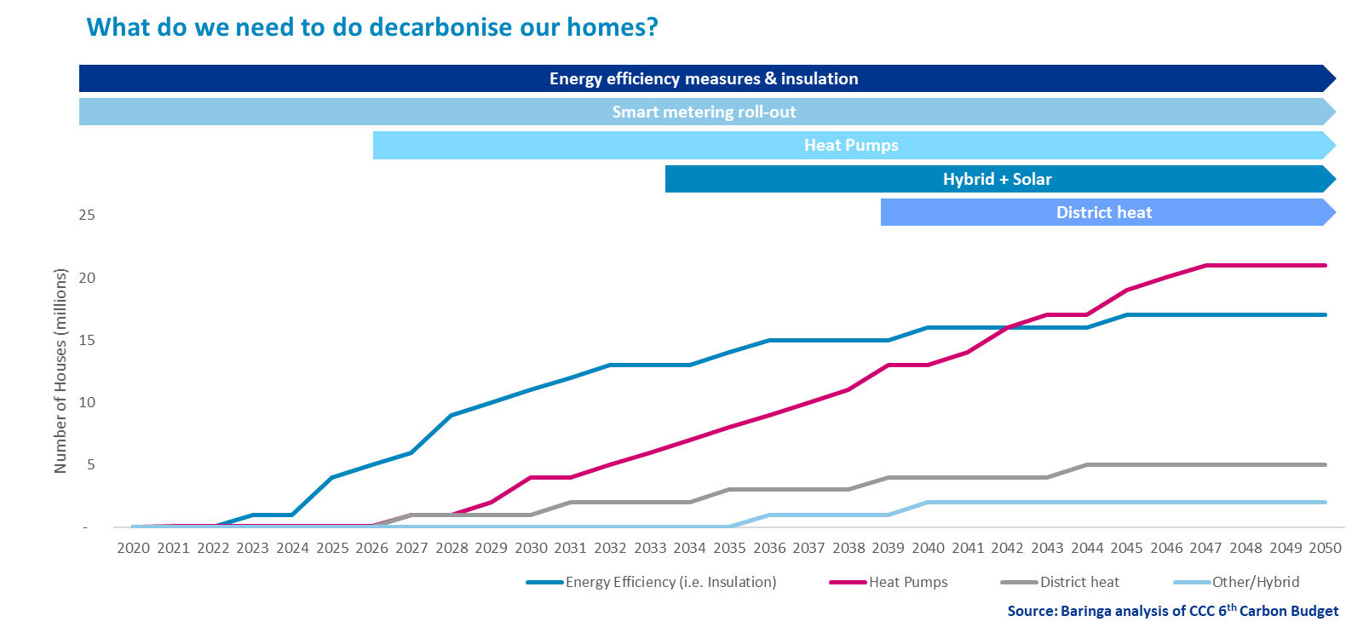

The Government recently committed to 600,000 heat pump installations per year by 2028, representing a 20-fold increase on current rates. It also committed £122m towards a Heat Network Transformation Programme and predicts up to £22bn may need to be invested in this technology to increase supply of heat from 2% to 18-24% of homes by 2050.

*What could this mean for DCC?*

Subject to changes to regulations there are a range of services that DCC could provide to support the decarbonisation of heat, such as:

* If secondary meters were introduced for heat pumps this would support both “heat as a service” and “comfort service” business models, enabling innovative propositions and competition.
* Secondary meters could enable data on asset energy consumption to be securely shared with manufacturers to inform bundling of energy services with their products. This would improve interoperability between assets and prevent consumers being “locked in” to a product or supplier.
* The DCC could provide a standardised and secure communications platform for connected heating assets to allow monitoring and control; however, improvements in latency will be required.

**Conclusion**

We foresee a bold and optimistic future for DCC as the secure digital spine of the energy system. A significant investment has been made by end-consumers in building the DCC infrastructure and we have proven we can work at scale on a 24/7 basis. The aim should be to make the greatest possible use in this unique national asset.

**Illustration of the potential future role of Smart DCC in supporting the transition to Net Zero – subject to appropriate regulatory changes**

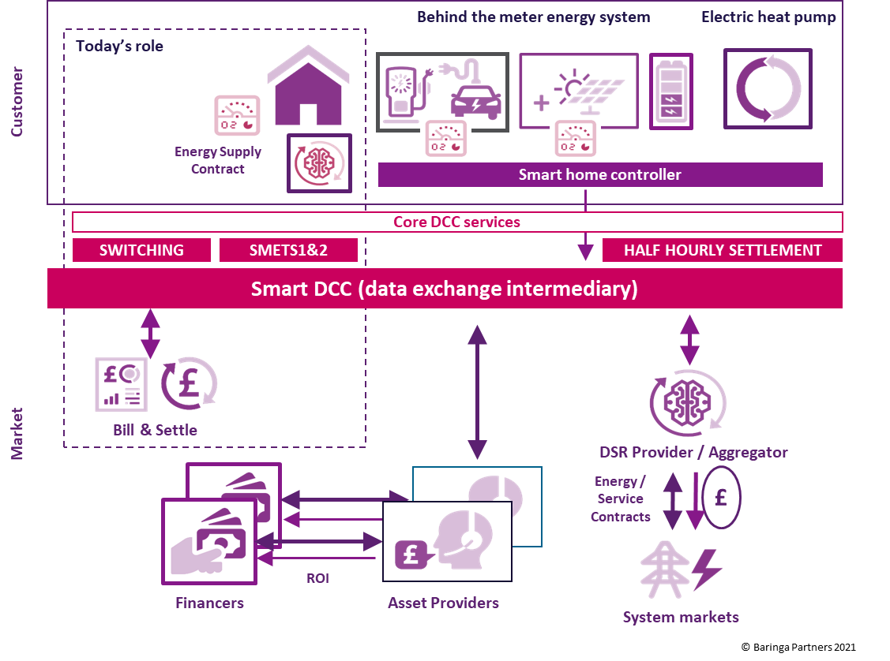

# Our priorities and plans

We believe in making Britain more connected so that we can all lead smarter, greener lives. This vision is a key driver of our priorities and plans over the next five years.

Through our highly secure national network, systems and ongoing operations, DCC has a critical role to play in helping the country to hit its net-zero carbon targets. Our system underpins the roll-out of gas and electricity smart meters to every household and small business in Great Britain, enabling more competition and delivering better outcomes for consumers. The successful roll-out of smart meters will bring the full benefits of accurate billing to households and businesses, giving them greater control of their energy use. It will also provide the basic building blocks which will support initiatives such as time-of-use tariffs, selling power back to the grid or controlling smart appliances.

Delivering the core smart metering platform remains our primary goal. We will build on our achievements over the last year, such as our ‘right first time’ commitment to enrol meters at the first attempt and will look to sustain and improve the rate of roll-out.

The DCC network is a platform which can support the energy industry more broadly. We are designated as a delivery partner for a number of Ofgem’s key programmes, including the Faster Switching Programme and Market-Wide Half-Hourly Settlement (MHHS). In addition, we have been appointed by BEIS to deliver the Enduring Change of Supplier (ECoS) Programme. Our Network Evolution Programme will be a key determinant of how we improve our services over the next few years.

Building on our primary goals, these workstreams form the fundamental deliverables and focus of DCC. Moreover, these will result in putting consumers in control of their energy.

Recognising the importance of articulating our priorities clearly, we developed five strategic pillars, which demonstrate the alignment to our primary goal. We set these out below.

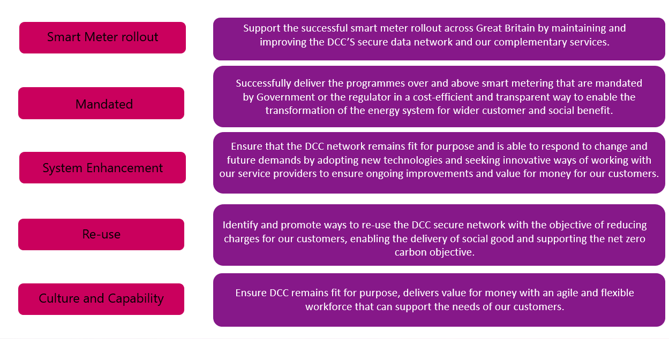

We have used these strategic pillars as the framework to articulate our plans and priorities and we also used it as part of our early engagement with stakeholders. This Business & Development Plan sets out how we are delivering each of the five strategic pillars, ensuring that - as DCC and our remit grows - we remain focused on delivery, fit for purpose and continue meet our core and mandated obligations.

We sought stakeholder feedback on our priorities and plans at a series of workshops and webinars in February and March 2021 and when discussing drafts of this plan. Their input has helped to shape this document. Figure x below summarises the key workstreams that are underway.





## Smart Meters - Support the successful smart meter rollout across Great Britain by maintaining and improving the DCC’S secure data network and our complementary services.

### Ensuring reliability and stability

The DCCs network is performing well against the Smart Energy Code (SEC) specification, with WAN coverage levels at 99.5% of properties in the North Region and 99.25% in the Central and South Regions. Nevertheless, we are conscious that we need to do more to support customers with the roll out.

We are paying particular attention to improving operational stability in the North region, working with our infrastructure partner Arqiva, device vendors and our customers to resolve key performance issues. We recognise that our previous efforts to improve this service did not resolve all the issues and that performance continues to fall short. We are achieving a green rating in 31 out of 34 of our service level performance measures, however we remain conscious that we need to resolve these outstanding issues.

We have launched a service improvement plan and, alongside this, Arqiva is also developing a plan to deliver infrastructure improvements. Our aim is to minimise risk and workload for our customers by delivering firmware upgrades to meters and communications hubs in a predictable and efficient manner.

We also recognise that, over time, some customer requirements have changed. We are keen to work with customers to better understand their needs so that we may facilitate those changes to the platform in line with the governance requirements.

### Service improvement plan

We have received Arqiva’s proposals for improving performance within the next six months. After analysis and discussion, we have agreed the following action plan:

* + **Action 1 – Stop jobs at 10 days not five.** Thiswill significantly increase the number of ‘right first time’ installations and reduce overheads for service users who will not have to rework requests
  + **Action 2 – More channels.** This will increase the throughput in the network and improve capacity
  + **Action 3 – Administration rate channels.** This will allow Arqiva to use the firmware download channel more efficiently and provide better utilisation of the network in quiet periods
  + **Action 4 – Firmware passes.** Cutting the number of re-broadcasts from 5 to 2 will reduce unnecessary noise on the network and improve capacity and stability
  + **Action 5 –Batching solution.** Internal trials have demonstrated that this significantly increases the number of jobs completed within five days
  + **Action 6 – Stopping ‘stuck jobs** **in image check state’.** Our modelling shows that this will not impact services users but will yield a step improvement in performance

There are two key working principles supporting the delivery of this plan:

* **Evidence-based review of action effectiveness.** For all six actions, we will take a series of measurements before and after to measure their success
* **Transparency with the industry.** We will keep the industry fully informed bysharing our plans, progress and outcomes with the relevant oversight bodies

### Enduring plan

Arqiva is also developing an enduring plan for the uplift of the network architecture to deliver improved infrastructure. This is an uplift to the existing specification and consists of four main system development releases and is scheduled to be completed by December 2021. These enhancements will deliver a significant improvement to firmware delivery and ‘right first time’ performance. Increasing the rate of transmission will greatly reduce job completion times.

DCC Service Management has taken thoughts and feedback from our service users and this engagement will continue throughout the performance improvement process.

We are confident that these measures will deliver a significant improvement in service and significantly increase capacity on the Arqiva infrastructure. Modelling and trialling have shown these developments will overcome the deficiencies we see in the current solution.

They have shifted the focus from purely percentage performance measurements to improving overall business outcomes for our customers. The longer-term enduring programme will build on these improvements, ensuring future reliability and stability.

## Dual-Band Communications Hubs

Dual-Band Communications Hubs (DBCH) will bring an additional 25% of properties in Great Britain within the scope of the smart metering programme, extending the coverage and benefits to approximately 95% of all GB premises. They have the capability to overcome some of the physical challenges which are holding back the smart meter roll-out, such as weaker signal strength in buildings with thick walls or in a block of flats where the meter is at the other end of the building and potentially out of range. Dual-Band Communications Hubs will improve the installation process, cutting out unnecessary assessment visits and reducing the number of failed installations caused by the limitations of Single-Band Communications Hubs.

There is an area of North Yorkshire which contains the RAF radar base at Fylingdales. To avoid any interference with the radar base, we will have to use a DBCH in this area which operates at a different frequency, though it will have the same devices and emulators as a standard hub.  This communications hub is expected to be available on the Certified Product List (CPL) and in supply by February 2022.

## Great Britain Companion Specification (GBCS)

The GBCS sets out data security and other operational standards for communications hubs. The Department for Business, Energy and Industrial Strategy (BEIS) continually reviews GBCS standards to ensure that data security is maintained in line with new and emerging threats. DCC is mandated by BEIS to develop, test and deploy new firmware (FW) to all operational communications hubs in line with each update of GBCS.

We are working to achieve compliance with the most recent updates of GBCS versions 2.1 and 3.2 in the North (Arqiva’s EDMI communications hub) and 3.2 in the South and Central regions (Telefonica’s WNC and Toshiba communications hubs).

We identified issues with some Single Band Communications Hubs (SBCH) which meant they were not capable of achieving the requisite CPA certification. Additionally, we identified other defects that needed to be corrected. These issues have resulted in a revised timetable which pushes out delivery from November 2021 to February 2022 to allow for issues to be resolved.

We anticipate delivery as follows:

|  |  |
| --- | --- |
| **Timeline** | |
| **GBCS 2.1 FW North Dual Band CH** | Now available on the Certified Product List (CPL) and expected to be in supply at the end of June 2021 |
| **GBCS 2.1 FW North Single Band CH** | Available on the CPL from the end of June and in supply November 2021 |
| **GBCS 3.2 FW North Dual Band and Single Band CH** | Both expected to be available on the CPL at the end of April 2022 and in supply by end of August 2022 |
| **GBCS 3.2 FW Central and South Single Band** | Expected to be available on the CPL mid-Jan 2022 and in supply end April 2022 |
| **GBCS 3.2 FW Central &South Dual Band** | Expected to be available on the CPL early September 2021 and in supply end of January 2022  For the Central & South regions the timeline is based on delivery of both Toshiba and WNC |

## SMETS1 migration programme

The SMETS1 Enrolment and Adoption Programme is a complex project involving multiple hardware and software combinations in a live environment. The programme will enable the migration of more than 17 million first-generation SMETS1 smart meters onto our system where they will be fully interoperable between energy suppliers. This will not only allow consumers to switch energy suppliers seamlessly without losing smart functionality but will also deliver significant savings to the industry. It will stimulate competition in the retail market and allow consumers to enjoy the full benefits of products and services which depend on smart metering.

DCC’s strategy is to enable the migration of SMETS1 meters in three main cohorts:

|  |  |  |  |  |
| --- | --- | --- | --- | --- |
| Enrolled Meters | Initial Operating Capability (IOC) | Middle Operating Capability  (MOC) | Final Operating Capability  (FOC) | Total |
| Cumulative | **2,864,406** | **1,261,678** | **186** | **4,126,270** |
| Active | 1,973,628 | 348,417 | 26 |  |
| Dormant | 890,778 | 913,261 | 160 |  |

The migration and operation of each cohort requires the deployment and integration of a new platform. The IOC platform was deployed in 2019, when migrations began, and the remaining two platforms for MOC and FOC were deployed during the year.

### Final Operating Capability

Once the capability to migrate and operate meters goes live, DCC must assess every unique combination of hardware and firmware due to be migrated to ensure they can all function in an interoperable way with our solution. These Device Model Combinations (DMCs) are assessed through a process called Device Model Combination Testing (DMCT) which requires us either to test each DMC or to assess it as being substantively equivalent to one that has already been tested. DMCs that have been approved through this process are added to the Eligible Products Combination List (EPCL), at which point they are available for migration. DCC has completed testing for all the DMCs that it can in the IOC and MOC cohorts (509) in total. This means that the maximum possible number of meters are available for migration in these cohorts according to current SEC rules.

There have been some issues with the firmware on SMETS1 communications hubs, forming part of the FOC cohort, that were identified by one of the active energy suppliers in the February 2021 cohort. This has delayed us in adding some device combinations to the eligible products list, with a knock-on effect on testing, meaning that migration of the Final Operating Capability cohort is still at a very early stage.

We are prioritising migration of the remaining dormant meters and we aim to complete these by the end of August 2021. Migration of active meters will be completed within the agreed 12-month timeframe as stipulated to suppliers in line with Ofgem requirements. However, this work needs to be done in collaboration with suppliers, as it is dependent on active energy suppliers resolving issues with FOC comms hub firmware.

### Performance

We have significantly increased the volumes of meters enrolled over the last 12 months. More than four million SMETS1 meters have been successfully enrolled on the DCC network, including 1.75 million previously ‘dormant’ meters which have had their smart capability restored. DCC have provided capacity to migrate 50 thousand installations a day.

Our migration performance remains strong, with over 99% of migrations delivered ‘right first time’ (RFT) every week.

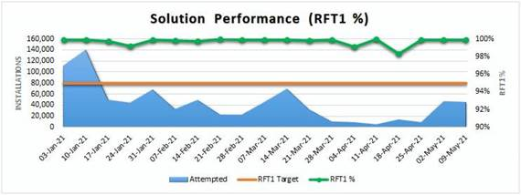

### Post migration

Our customers have welcomed the fact that our Migration Control Centre (MCC) and Early Life Support (ELS) capabilities are now established and have matured, helping the industry to coordinate meters in readiness for migration and providing real-time monitoring post migration to ensure a seamless transition.

Following successful migration, it is imperative that energy suppliers make the meters operational to ensure that the consumer can fully benefit from the SMART functionality. We are working closely with industry, BEIS and Ofgem to ensure they are made operational as quickly as possible.

* 57% of all dormant meters have been made operational following migration and we are working to ensure that as many as possible can operate in smart mode
* 98% of active meters have been made operational following successful migration on to the DCC Network
* We have established a security testing capability for SMETS1 devices to protect the DCC system
* Consumer switching has increased. 316,154 meters on our network have registered a change of supplier since migration, representing 8.14% of the total at the end of March 2021.

### Working with our customers

We recognise effective communication with our customers will ensure that we can successfully deliver the SMETS1 migration. We have run regular multilateral and bilateral SMETS1 industry engagement sessions during the year and has provided regular updates via a range of industry forums. DCC has also continued weekly governance meetings with BEIS.

DCC now provide regular migration and operational reports at various forums such as Implementation Managers Forum (IMF) and the Smart Meter Delivery Group (SMDG).

## Network Utilisation and capacity planning

We report regularly on the performance of our products and services through a variety of different channels including monthly, quarterly and annual performance reports – all of which are available from our Technical Operations Centre. In the context of our development plans over the next five years, the following snapshots summarise the current condition of the system and assess its future capacity.

### Volume of installed meters

Smart meters commissioned on DCC’s network increased by 6,670,619 between April 2020 and March 2021, taking the total to 10,782,580 or approximately 20% of all meters in Great Britain.

These commissioned smart meters comprise of 3,856,943 first-generation (SMETS1) smart meters and 6,925,637 second-generation (SMETS2) meters. Growing at an average rate of more than 20,000 a day, we anticipate reaching 20 million active, connected smart meters commissioned on our network by March 2022.

### Network coverage

SMETS2 Communication Service Providers have now delivered against their maximum contracted Smart Meter Wide Area Network (SMWAN) coverage levels across Great Britain. These contracted coverage levels are at least 99.5% of properties in the North Region and at least 99.25% in the Central and South Regions.

|  |  |  |
| --- | --- | --- |
| Communication Service Providers Coverage Levels | | |
| CSP North | | |
| Date Due | Percentage of Properties | Delivered |
| 01/01/2028 | 99.25% | Yes |
| 01/01/2019 | 99.35% | Yes |
| 01/01/2020 | 99.40% | Yes |
| 01/06/2020 | 99.55% | Yes |
|  |  |  |
| CSP South | | |
| Date Due | Percentage of Properties | Delivered |
| 01/01/2028 | 97.75% | Yes |
| 01/01/2019 | 97.75% | Yes |
| 01/01/2020 | 97.75% | Yes |
| 01/01/2021 | 99.25% | Yes |
|  |  |  |
| CSP Central | | |
| Date Due | Percentage of Properties | Delivered |
| 01/01/2028 | 97.75% | Yes |
| 01/01/2019 | 97.75% | Yes |
| 01/01/2020 | 97.75% | Yes |
| 01/01/2021 | 99.25% | Yes |

### Historic incident levels

The number of incidents per communications hub has fallen and stabilised over time. The downward curve of incidents per installation demonstrates the extensive service improvements that DCC has delivered this year to improve processes while also working with customers to reduce the number of post-commissioning obligation failures. We continue to engage with service providers and device manufacturers to drive down incident volumes even further.

### Alert incident types – volume management

As the SMETS2 platform scaled up, it became clear that the number of alerts generated was significantly higher than anticipated and referenced in the Invitation to Submit Final Tender (ISFT) document. After careful analysis, we determined that there were several distinct groups of alert types: customer behaviour, meter issues, pre-payment interface device (PPMID) issues, Comms Hub issues and most commonly, interoperability issues between meter, PPMID and Comms Hub variants.

Swift action to assess the issues and find solutions significantly reduced the volume of alerts. Between their peak in June 2020 and March 2021, they fell by 40%. At their peak in June 2020, individual meters were on average generating 16 alerts a day, by March 2021 this had fallen to 6 per day. As an additional measure, we have increased the scale of the Data Service Provider solution in order to manage the higher-than-anticipated volume of alerts.

### Working to resolve issues

In our drive for transparency, we shared the results of these activities on a monthly basis with the industry, both directly on a one-to-one basis and more broadly through industry groups. Key actions included:

* Direct liaison with customers to inform and agree remediation plans
* Working with DCC suppliers to fix issues and mitigate impacts
* Collaboration with customers and meter manufacturers to analyse and mitigate interoperability issues

As migration of SMETS1 meters increases, we are taking the same approach of reporting progress on a regular basis and working with our customers and external suppliers to mitigate any risks.

### Testing Capacity

Our 19 labs at Brabazon House in Manchester provide flexible and modular space to support our customers’ testing requirements. Here we aim to develop a clear understanding of usage profiles for future releases, firmware upgrades and new device types. Our customers and other users can also use the labs to test their own products.

### Forecasting of core communication and connectivity capacity

DCC performs regular capacity planning in order to meet our service users’ business needs and to anticipate demand from potential new requirements. This allows us to prioritise investments in new components to support planned growth and to make sure that capacity stays in step with demand. We monitor and model service traffic, service performance, service utilisation and the supporting infrastructure. We engage with our partners to build strategic plans that address the future requirements of the service and enhance its resilience and agility as it scales up.

All devices generate service request messages, which our customers forecast quarterly for the following eight months. We combine these with operational insights in order to create a long-term aggregate forecast of traffic through the communications infrastructure.

The increasing breadth and depth of high-frequency data captured today by DCC is being leveraged to provide more accurate short and long-term forecasts for load and system performance predictions, which inform design improvements and demand response actions.

### Impact of COVID-19

In the wake of the COVID-19 pandemic, smart meter installation volumes fell by 95% during the first nationwide lockdown from late March 2020 as non-essential visits were halted. Installations returned to their pre-COVID volumes by September 2020, before the second nationwide lockdown in November 2020 drove installation volumes down again, but this time by just 2.5% month-on-month. By March 2021 installation volumes had largely returned to their pre-COVID levels.

### Forecast of SMETS2 and service volume requests

In March 2021, the DCC network carried almost 400 million service requests, at an average rate of 147 per second. Between April 2020 and March 2021, service request volumes increased by 240 percent in response to the growth in the number of smart meters commissioned on DCC’s network. Once all meters are commissioned on the network, we expect to carry more than 3 billion service requests a month, at an average rate of 1,100 per second.

In addition to these service requests, the DCC network carried 1,323,607,415 device alerts in March 2021. Device alert volumes are much greater than expected when the system was designed. There are many reasons for this, including communication hub and meter interoperability issues, firmware defects in OEM (Original Equipment Manufacturer) products and the side effects of customer behaviour. As discussed at 6.5.4, DCC is working to manage these device alert volumes down.

### Service Centre Capacity

The DCC Service Centre provides a primary point of contact for all service users regarding operational matters for both SMETS1 and SMETS2 services. It operates 24 hours a day, 365 days a year and is delivered from both the Manchester and Ruddington offices, with a current team of 70 people split across both sites.  Since the start of the live service, this capability has been provided under contract by Capita plc.  A contract extension has been agreed with Capita for the next 2 years predicated on no headcount increase for the SMETS related workload. The rationale behind this is twofold:

* Installation-related failures will reach a ceiling as the maximum number of trained installation engineers are rolled out
* The numbers of new SEC parties onboarding on to the DCC system will tail off

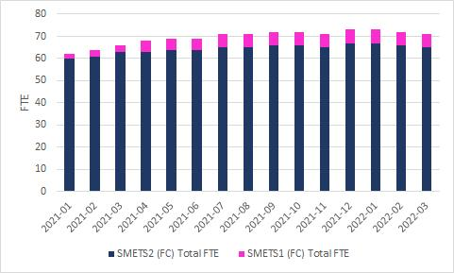

Capita has a proven Service Centre track record.  In the four years it has been working with DCC, it has acquired extensive knowledge and experience of the smart metering network.  This knowledge has enabled it to deliver efficiency and effectiveness programmes, improving overall customer experience and reducing cost.  It has consistently delivered against all service measures, absorbing work into the current headcount resulting in a £2.63 million saving in 2019-2020, with a current total full-time headcount of approximately 70 people against a previous forecast of 113.

## Enduring Change of Supplier (ECoS)

### Overview

Smart metering devices use secure, signed certificates to validate that remote parties are authorised to communicate and operate them. One of these certificates relates to the energy supplier and so needs to be refreshed whenever a consumer switches supplier to ensure that billing is correct. When smart metering was first implemented, a temporary solution was introduced, known as Transitional Change of Supplier (TCoS) so as to minimise the impact to suppliers during the mass roll-out of smart meters. This is now being replaced by a permanent, long-term solution known as Enduring Change of Supplier (ECoS), which provides a greater degree of separation between the different elements of our supply chain.

Ofgem appointed DCC as the supplier of the main application and we set up the ECoS Programme to deliver the capability.

### Timescales

Over the next year, the ECoS Programme Team will work with the industry and Ofgem to ensure smooth delivery, followed by the migration of the existing TCoS certificates to the new ECoS certificates. This will reach over 25 million devices by April 2023.

Moving to a segregated supply model will require us all to work together when problems arise during both the development phase and launch of the live service. Procurement for the ECoS programme has focused heavily on ensuring collaborative undertakings from all suppliers. The design build and test (DBT) phase is due to be completed by June 2022, at which point DCC will stand up the live service. Migration from TCoS to ECoS will take place from June 2022 to April 2023.

## DNO Transformation Programme

We recognise the that we need to improve the customer experience of Distribution Network Operators as a core customer group and improve their confidence in us as a strategic partner. The DNO Transformation Programme will address deficiencies in the current service and so ensure that DNOs can expect the same levels of services as our energy supply customers.

### Benefits

The programme will establish accurate, automated dashboard reporting for key performance indicators and develop data insight to enable performance improvement. It will tackle the backlog of issues affecting DNO integration so that the DCC system provides the right information at the right time. It will also improve effectiveness of industry device testing for DNOs and feature a strategic DNO Engagement workstream.

DCC will deliver accurate and reliable reporting to DNOs on a validated list of requirements. Interim dashboards will be available by June 2021 and a full version by September 2021.

Using the cost benefit analysis[10], it is estimated that a potential £374 million in network benefits can be delivered by DNOs through better outage detection and management, and improved decision making about network investment (see table xx). Monitoring voltage across the network allows the DNO to spot likely future faults. Alerting DNOs to power outages forms a significant part (£170m) of the benefit dependency.

|  |  |  |  |  |  |  |  |
| --- | --- | --- | --- | --- | --- | --- | --- |
|  |  |  |  | | Benefit Dependency | | |
|  | CBA Benefit Type | | | CBA value (£m) | Power outage alert | Consumption data | Voltage quality |
| 1 | Earlier fault notification | | | 40 | **\*** |  | **\*** |
| Faster restoration of Supply | | | 90 | **\*** |  |  |
| Reduced operational cost for fault fix | | | 20 | **\*** |  |  |
| Reduced operational cost for call centres | | | 20 | **\*** |  |  |
| 2 | Optimised network reinforcement costs | | | 170 |  | **\*** | **\*** |
| Optimised new connections costs | | | 40 |  | **\*** |  |

**c. £170m benefit dependent on Power Outage Alerts**

We intend to work with DNOs to manage incidents more effectively. We will develop processes to identify and address device-related defects, working closely with device manufacturers and tracking issues through to resolution. We are assessing how we can improve engagement with DNOs in device testing and existing services.

## Smart Energy Code (SEC) System Releases

### In-Life Change Programme

The Smart Energy Code (SEC) is a multi-party agreement and defines the rights and obligations of relevant parties involved in the end-to-end management of smart metering. SEC Modifications are industry-wide requests for changes to our services and we are required to deliver two SEC System Releases each year in June and November.

In early 2019 we established a dedicated In-Life Change (ILC) team to focus on the delivery of SEC Modifications. This led to the first successful delivery of a SEC Systems Release in November 2019.

### Benefits

A further release was delivered in June 2020 ahead of schedule and under budget, with a cost saving of £6 million. The November 2020 release was delivered on time and within budget.

Throughout 2020, we continued to improve our ILC process and system designs, including the development of dashboard reporting and fixed-price impact assessments, giving better visibility of progress throughout the release cycle.

### Forward look

SEC releases this year relating to SMETS2 meters will include firmware updates to specific home area network (HAN) devices and additional technical specification changes (known as SECMP0007). These will be delivered over multiple releases due to their size and complexity.

The November 2021 release is on track, we have defined the scope of releases for 2022, and planning for 2023 is already taking place.

Power Outage Alerts (POA) changes are due to be delivered as a SEC Modification and are scheduled for the November 2022 release. This will improve the timing, speed and quality of outage and restoration alerts and significantly support our DNO programme.

The ILC team is supporting a cross functional team established in response to the Retail Energy Code (REC) governance process, looking specifically at how the changes will be delivered. This will bring together all the Smart Energy Code rules governing retail energy activities, including faster and more reliable switching. It will also guide our preparations for and operation of the new Central Switching Service. We will add SMETS1 to the ILC programme later this year.

### Improving oversight and governance

We recognise that we must be more proactive with service providers in solution design. To achieve this, we are creating a new role of Head of Design who will provide oversight on end to end design process for all system changes that go through the SEC modification process.

We are implementing a wider, co-ordinated approach to change across DCC and providing better visibility of all the enabling services, such as testing. To help this, the ILC team proposes to take ownership of non-SEC changes, excluding maintenance, and to co-ordinate them through a single annual release.

## Standardised customer analytics reporting

Over the past year, we have invested significantly in analytics reporting and monitoring to identify the causes of performance failings across the DCC ecosystem. The reporting that we have developed help both customers and DCC to identify issues with the system. It has identified differences in performance between our Service Providers and customers. The Service Delivery Management team picks up those differences and address with the Service Providers. Where there are differences in our customers performance, they are addressed via our Service Management team. We have measured the difference in average performance across all variables in shared systems and we intend to use this work to support all parties to make improvements.

We are working with all our customers to identify the key metrics for each of the business processes that they initiate within DCC systems. We will then create standardised reporting packs, with their input, which will include:

* Performance measures against industry average and industry best for benchmarking
* Anonymised league tables
* Datafiles for business processes, enhancing customers’ ability to diagnose issues
  1. Examples of the types of reporting to be included within the new packs can be seen below.

Graph 1: Success rate for a specific Service Request Variant (SRV 6.23 in this instance) of an individual SEC party tracked throughout the month against the industry average for that SRV.

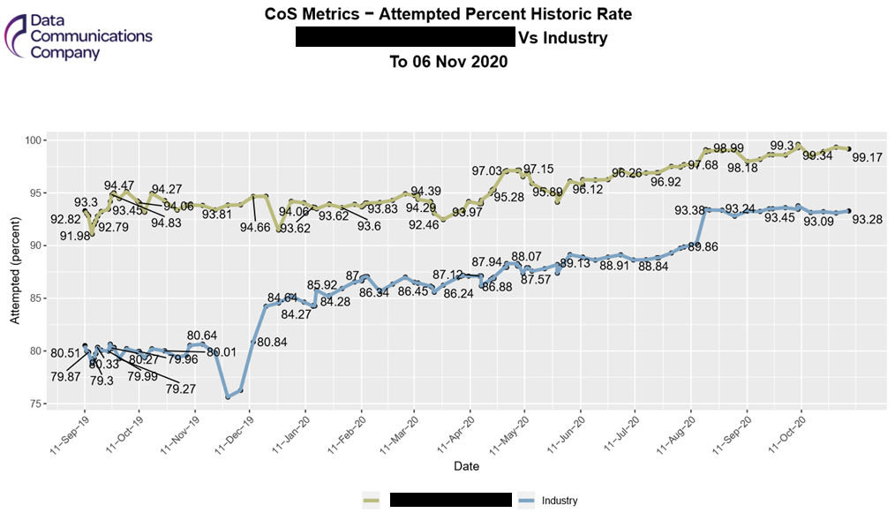

This will allow all customers to create a roadmap of improvement based upon their individual business priorities. DCC will support them in the delivery of these via its existing teams, service providers and forums.

Discussions with our customers (via the Business Development Planning process and individual workshops) have suggested that the appropriate mechanism for this reporting would be via an appendix to the Smart Energy Code. Following agreement of customer requirements, DCC will therefore be raising a SEC Modification to progress delivery. It is anticipated that this will occur by the end of June 2021. Dependent on timescales agreed with industry, DCC should begin delivering an initial build for this functionality from Autumn 2021.

## Mandated Programmes - Successfully deliver the programmes over and above smart metering that are mandated by Government or the regulator in a cost-efficient and transparent way to enable the transformation of the energy system for wider customer and social benefit.

DCC has been selected by the Government to deliver several key changes in the retail energy market which closely align with our core smart metering programme. We are Ofgem’s designated delivery partner for several initiatives, including the Faster More Reliable Switching Programme and the Market-Wide Half-Hourly Settlement Programme and the Enduring Change of Supplier Programme.

In addition, we are in discussion with BEIS about potential future applications of DCC capabilities as a means to deliver further policy objectives within the energy sector.

## Reforming the retail market

## Faster switching

### Overview

As Ofgem’s key delivery partner, we are helping to bring about significant change in the energy market which will make next-working day switching a reality. This requires us to manage the consolidation of 27 existing and new systems and the integration of about 200 licensed parties into a single core system, the Central Switching Service (CSS). In October 2020 the programme underwent a managed re-plan requested by the industry as a result of the COVID-19 pandemic. As a result, the ‘go-live’ date for the new service has been rescheduled to the summer of 2022.

### Milestones

The switching programme is on track and several key milestones have been achieved.

|  |  |
| --- | --- |
| **Action** | **Status** |
| Pre-Integration Testing | Completed (February 2021) |
| Systems Integration Testing (SIT) of the CSS and its interfaces | Completed (March 2021) |
| Non-Functional Testing of the data migration processes | Completed (April 2021) |
| User Integration Testing (UIT) Part 1:  Entry Process Testing (ensures that energy suppliers can connect to the CSS) | Commenced (May 2021) |
| User Integration Testing (UIT) Part 2:  End-to-End Testing (ensures that full switching process works as designed) | Commenced (May 2021) |
| Testing of transition processes to new system | Due October 2021 |
| Operational Testing (OT), Tranche 1 and 2 | 10 September 2021 |
| UEPT Test Assurance (all tranches) | 26 November 2021 |
| E2E Testing scheduled to complete | 15 December 2021 |
| Completion of Transition Testing Stages 1, 2 and 3 | 04 March 2022 |
| REC v3.0 Go Live | 16 May 2022 |
| Readiness Assessment for Go/No Go | 27 May 2022 |
| Go-live date for new system | Targeted for 06 June 2022 |

### Address data

We are paying a lot of attention to the quality of address data for domestic consumers, something which is essential to improve the switching process. We have completed the initial work of automatically matching the industry’s address data to a “gold standard” address database. We have also completed the pilot phase of our interactive address matching project. This is focused on improving the quality of addresses which are more difficult to match. We are working with source data providers to improve overall data quality by ensuring that meter points are accurately matched to premises’ addresses. This will save consumers time and inconvenience when switching, as well as reducing costs for suppliers.

### Technology roadmap

We wanted to ensure that the switching system remains fit for purpose, so we commissioned a roadmap analysis of the changes and innovations likely to affect switching in future years. This work influenced our choice of the solution we procured from our service provider Landmark. From day one, it will have the functionality to handle any future large-scale increases in switching, ensuring that the system can remain agile and meet the needs of our customers for many years to come.

### Working in partnership

Effective engagement is essential if we are to make the transition to faster, more reliable switching. We have hosted two ‘Switching Summits’ with the industry, held entirely online, and organised several shorter, focused online briefing sessions on topics of interest, such as service management of the CSS.

We continue to support the programme’s Consumer Journey Forum, which was set up to ensure that energy suppliers and the programme team understand the impact on consumers of introducing the new switching arrangements. We have conducted research into consumer views on switching and the barriers they experience.

## Market-Wide Half Hourly Settlement (MHHS)

### Overview

The introduction of Market-Wide Half Hourly Settlement (MHHS) will increase competition in the energy market to the benefit of the end consumer. Access to half-hourly data will allow industry participants to build and bring new offerings to the market, differentiating themselves and providing the consumer with increased choice. This will build on the benefits that the national roll-out of smart meters is already delivering.

Ofgem has decided that medium to large non-domestic customers cannot opt out of MHHS. Domestic and small non-domestic customers may opt out. Implementation is expected to take four years and six months, with completion in October 2025

### Initial steps

To ensure our readiness, we have engaged fully with Ofgem’s MHHS team and other energy partners. We have attended Ofgem’s architectural working group to help shape the Target Operating Model (TOM), which is the preferred method for introducing MHHS, and participated in the consultation process, providing cost modelling and other analysis.

DCC will raise the SEC Modification on behalf of Ofgem and work in partnership with the regulator to support the change through the SEC governance process.

We have produced an initial end-to-end project plan which has been fed into Ofgem’s wider integrated programme planning. The changes implemented by us will be part of a much wider industry change programme, largely based on the Balancing and Settlement Code (BSC), but also affecting the Retail Energy Code (REC) and Distribution Connection and Use of System Agreement (DCUSA).

### Timescales

We plan to have a final solution agreed with costs by February 2022 and are anticipating start of Systems Integration Testing in January 2023, ahead of final implementation in the November 2023 SEC Release.

Ofgem will be setting up a new Strategic Programme Management structure to govern the implementation of MHHS, though DCC will still be expected to report through the SEC governance process and update the wider programme on progress.

We will need to make the necessary system changes across our network to accommodate the volume of MHHS data and its recovery at regular intervals. This will include changes to SMETS1 and SMETS2 architecture.

### Proposed milestones

|  |  |
| --- | --- |
| **Action** | **Status** |
| SEC change process started | April 2021 |
| SEC change process completed | January 2022 |
| Non-SEC changes delivered | Nov 2022 |
| DCC Design Build Test (DBT)completed | January 2023 |
| Meter Data Retriever User Integration Testing completed | April 2023 |
| Central Settlement System Ready for migration | September 2024 |
|  |  |
| Start of Unmetered Suppliers/Advanced Meters migration | October 2024 |
| Start of smart/non-smart migration | November 2024 |
| Migration complete | October 2025 |
| New settlement timetable | November 2025 |

## Electric Vehicle - Smart Charging

Current industry estimates are that 60–85% of Electric Vehicle charging will take place in private (at home, either on private driveways or on street, or at work) and 15–40% in public spaces[11] To meet this demand, more than 20 million private charge points will need to have been deployed GB-wide. A transition of this scale requires significant investment and effort. It will need to balance several outcomes including:

1. The customer’s requirement for a charge sufficient to compete their journey
2. Network constraints
3. Electricity system generation, both capacity and potentially carbon intensity

Considering these, the Government has set out the following objectives for EV charging infrastructure:

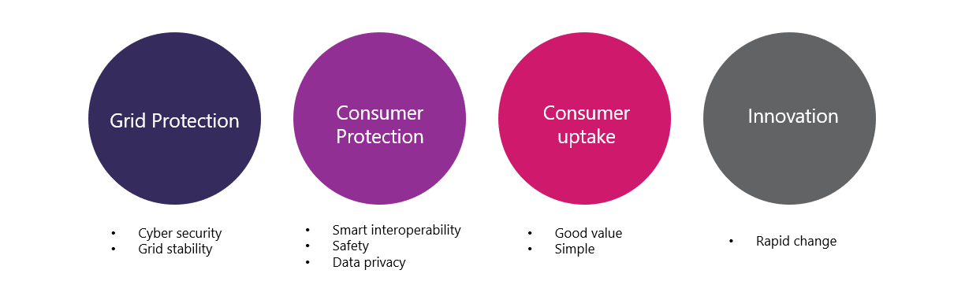

The Electric Vehicle Smart Charging Consultation 2019[12] aimed to outline the Government's approach and objectives for smart charging of EVs. This consultation also identified the smart metering system as a solution for EV smart charging, as it could achieve both full interoperability for consumers and end-to-end cyber security - achieving the objectives on Consumer Protection and Grid Protection.As the energy sector continues to transform in response to the Net Zero target, a digital platform will be key to facilitating the scale and pace of change set out in Government's recent Energy White Paper.

We are exploring, with BEIS, the potential for the smart meter infrastructure to provide a flexible EV smart charging network with security, scalability, and interoperability at its heart.

## System Enhancement - Ensure that the DCC network remains fit for purpose and is able to respond to change and future demands by adopting new technologies and seeking innovative ways of working with our service providers to ensure ongoing improvements and value for money for our customers.

### Network Evolution - Overview and benefits

The Network Evolution Programme focuses on the future of DCC operations in the smart metering environment. It explores how new processes, systems and technologies can improve the live service, reduce the operating costs of our system, and, above all, secure the continuity of a critical part of the UK’s national infrastructure. Network Evolution was triggered by; the future obsolescence of the 2G communications network, the forthcoming Data Service Provider (DSP) re-procurement, evolution of the network to take advantage of lower cost technology improvements such as cloud-based services

The programme comprises four distinct programmes:

* **Network Evolution DSP (Data Service Provider).** Designing and procuring data services which are secure and sustainable, with a reduced operating cost, capable of rapid and cost-effective change in response to market and customer demand. This work will include investigations into how cloud computing and microservices could contribute to a new design for the DSP to de-risk the overall re-tendering activity.
* **Network Evolution Communication Hubs & Networks.** Designing and procuring future-proof communications hubs and networks (CH&N). We require a technology with a longevity of at least 15-20 years so that the full benefit of assets’ operational life is realised from the point of installation.
* **Network Evolution SMKI.** Securing a tactical extension to the Smart Metering Key Infrastructure (SMKI) security service in a cost-effective way, followed by a strategic procurement of the enduring solution.
* **Network Evolution Test Automation:** Designing and implementing automated testing of Smart Energy Code releases to achieve faster and lower-cost testing with additional enhancements that will allow DCC to confirm the efficacy of changes.

The Network Evolution Programme is driven by advances in digital technology which continue to reshape the energy landscape. We must make sure that the DCC Network keeps pace with and prudently anticipates that change, while also maintaining continuity of service to the energy industry as contracts with service providers expire. These issues are being addressed urgently for a variety of reasons:

* The contract for the provision of the DSP service with CGI is coming to an end and must expire by October 2024. The contract with CGI allows for up to three one-year extensions with a final termination date on 31 October 2024. DCC will notify CGI of extension by 18th June 2021 to provide; stability for workstreams with “Go-Live” dates scheduled beyond the existing contract expiry date and to ensure outcomes are met for the design, procurement and migration strategy for the future DSP.
* The existing 2G/3G networks, in use in the South and Central regions, have been superseded by the introduction of 4G networks, with 5G on the horizon. There is a high probability that the older networks will no longer be supported or maintained in the medium term and the DCC will need to modernise its communications provisions accordingly.
* SMETS1 and SMETS2 assets have a 15-year life, so the earlier an enduring technology can be made available in the ecosystem, the lower the amount of scrappage and the longer the economic life of assets.
* BT’s contract for the SMKI security service, also known as Trusted Service Provider (TSP), is due to expire in April 2022. A new tactical solution will be implemented before this date on a three-year plus one-year agreement, while an enduring TSP Programme has been set up to re-procure all TSP Services by April 2025.
* There is a continuing need to drive competition within the supply chain to reduce costs, improve service and accelerate continuous improvement by, for example, adopting a future testing strategy which provides automated set up.

Network evolution aims to ensure that customers always obtain value for money and that opportunities for competition are integral, so that all service providers are subject to continual competitive pressures. We have agreed the CH&N outline business case with the Department for Business, Energy & Industrial Strategy (BEIS), the SEC Panel and its subcommittees. We continue to engage with our customers as we prepare the final business case for BEIS consideration and develop the outline business case for network evolution DSP.

### Timescales

The aim of the programme is to deliver a ‘future state’ Data Services Provider by October 2024.

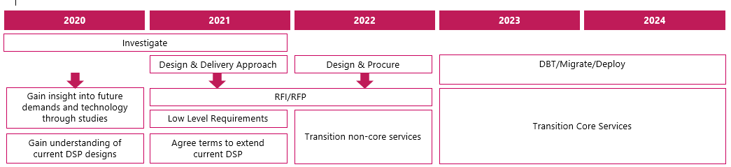

The overall programme is in the early phases of development, as follows:

* DSP is at the scoping phase, to define what the future business, technology and security landscapes, opportunities and challenges look like over the next 10-plus years. We are consulting with the industry on the future services to be delivered. The new DSP will be procured to be built, tested and deployed at the earliest opportunity, and by October 2024 at the latest. DCC have notified CGI for up to three one-year extensions with a final termination date on 31 October 2024.
* CH&N is at the shaping stage and is running a procurement for 4G Single-Band Communications Hubs to come to market in 2023, with dual band to follow in Q2 2024. DCC are also exploring the option to upgrade this with further services such as roaming and switching.
* The TSP Programme has concluded an investigation phase in collaboration with the National Cyber Security Centre (NCSC). In response to BT’s existing DigiCert Symantec SMKI platform retiring in April 2022, our TSP platform will be enhanced in two phases​, first a tactical extension of BT services from April 2022 to April 2025, migrating to a new BT platform. Followed by a full re-procurement of enduring TSP services, with requirements gathering commencing early 2022 and implementation by 2025.
* Our test automation and robotics workstream is currently running an active procurement exercise against an agreed design agreed with customers with a target of deployment in Spring 2022. This will enable 24/7 working and a significant reduction in the time and cost to complete regression testing

The programme will deliver over the next three or more years. Other than next-generation communications hubs and test automation, precise timescales are yet to be confirmed for these outcomes and more work is required on the approach to be adopted in each area. DCC will continue to engage with our customers and stakeholders on Network Evolution. It is critical to our success to ensure that we listen to the feedback from our customers and stakeholders and use this feedback to help shape our design and delivery plans.

### Elective Communication Services

The Elective Communication Services (ECS) process allows an existing customer to commission DCC to develop bespoke messaging services on our platform. These new ‘elective services’ are delivered on request with a six-month exclusivity period.  To date we have seen very low demand for this service. Our customers tell us that they see it as too expensive, too slow and too restrictive, both in terms of its technical scope (limited only to new message types) and short exclusivity period.

Accordingly, we are engaging with customers on a proposed overhaul of the ECS process to provide ‘self-serve’ access to DCC capability that would enable them to develop new products and services in the way that they want. Customers have told us they require simple, self-service on demand capability with clear pricing in advance. DCC has completed market engagement to inform customers of the outline business case for making the required changes to our platform and system for the redesigned process. In 2021 DCC will support a series of pilots with customers to ensure that we get the revamped process correct and fit for purpose.

Subject to customer feedback from the pilots, we will explore the regulatory changes needed to redefine the ECS process within the Smart Energy Code. This will include confirmation of the scope of the revamped process, the preferred route to enable regulatory change, and what the preferred funding and financial model for our customers would look like. We expect all the investment in the revamped ECS process to be paid back by ECS users and this will be covered in a detailed business case with costed options that we will share with customers later in the year.

|  |  |  |
| --- | --- | --- |
| Activity | Summary | Timescales |
| ECS Overhaul | Establishing pilot projects and assessing the regulatory viability of wholesale SEC changes to the process | Commence pilot projects in H2 2021/22 |

### DCC Operations - Operating live services

DCC Operations will continue to face significant challenges over the coming years, including the increasing volume of SMETS2 installations, the migration of dormant and active SMETS1 meters and the launch and early life of the new Central Switching Service. To ensure that we are ready to face these challenges effectively, we have taken several steps across all core elements of the live service.

### Operational customer relationship management

We recognise that we have not always been effective or proactive in our day to day customer engagement and often not adapted our processes to support users in the bespoke manner they require. We are in the process of reshaping our service operations team to be more effectively aligned to different customer types. Teams will be designated to specific customer groups so that they can build knowledge and understanding. We are working with meter manufacturers to better understand their products and in the past 12 months we have performed joint investigations with them, allowing us to resolve many issues. This will approach will continue to strengthen our knowledge and capability to support customers.

### Improving knowledge

In addition, we are investing in our knowledge development so that we can better support our customers, working with meter manufacturers to better understand their products. In the past 12 months we have secured positive engagement, where we share issues and perform joint investigations. The outcome is that we have helped to address multiple issues.

### Improving ways of working

We recognise that the SEC modification process can be too long. We have tried to reduce this by running a number of SEC modification trials with the support of our customers. The trials have been a positive step, and we found that the refinement stage was reduced by around 50%. Overall, this means, shorter lead times and less effort because the final SEC modification is already agreed, understood and demonstrated. We will continue to review and refine this process over the coming year.

## Enhanced Testing

Our test services support new and existing customer requirements. Additionally, customers benefit from a range of enhanced testing services, such as device user system testing for change of supplier or comms hub firmware upgrades and early connectivity testing. There is more that we can do to support customers within testing environments, such as improving device assurance for interoperability and building a baseline interoperability and testing standard for DCC and industry,

Additionally, we recognise that we can offer more information and guidance that will support customers to navigate and undertake testing services.

|  |  |
| --- | --- |
| **Initiative** | **Description** |
| Optimise TS reporting | Optimise reports produced by Testing Services. |
| CRM | Introduce CRM tool as a centralised place for all Customer info, to ensure the data is accurate and accessible |
| iLMS | Further develop functionality of test lab tool – iLMS to increase reporting capability, Customer self-service and data accuracy |
| DCC website review | Review and update of the content on Testing Services’ pages on DCC website. |
| Team’s training plan | Develop a training plan for the whole Testing Service area taking into account capability levels identified in the skills matrix |
| Quality of info/documents | Increase quality of information that is published to Customers in order to reduce number of queries |

## Security

DCC has developed strong security expertise and capability but we need to build on these foundations to reflect the growing scale of our operations and to meet emerging and existing threats. We have identified four areas where we need to focus if we are to maintain the necessary level of protection for our services, people and assets.

### Information management

The introduction of faster switching means that DCC will become a significant data controller, so we must enhance our personal data management safeguards. We are implementing a new business-wide information management policy that ensures consistent handling and storage of data in line with ‘secure by design’ principles, enhancing compliance with all relevant data protection regulations and legislation.

Following an audit of information assets in Spring 2021, this programme is now under way and expected to complete by the middle of 2022.

### Threat-led defence

In 2020 we piloted a threat-led security framework (called MITRE ATT&CK) with our SMETS2 Service Providers and this will be rolled out fully over the next two years across all aspects of the DCC business. This will ensure that we understand threat actors better and can model threat scenarios more accurately, with a clearer idea of where attacks are likely to come from. We will also apply this methodology across our supply chain. This refined defensive approach will help to reduce risk to a level that is in line with our low-risk appetite and protects our best-in-class security reputation.

### Zero-trust approach

“Zero trust” means trusting nothing without the necessary authentication that it is genuine and has not been tampered with. This approach will help to reduce the most common risks and address the security architecture weaknesses caused by the proliferation of cloud services, multiple access routes and collaboration technologies.

We will begin adopting this approach with some programmes – including Data Service Provider re-procurement - within the next financial year, but it will take up to three years to embed it across the business.

### Demonstrable compliance

We need wider and more consistent compliance techniques to allow threat-based risk assessment of our supply chain and we need more accurate reporting to meet our regulatory obligations.

This requires repeatable but rationalised techniques that generate accurate and viable compliance data without exposing our people and partners to audit fatigue or activities which do not render useful intelligence. For Core Service Providers, there will be more focus on continuous compliance assessment throughout the year rather than annual assessments. We are backing this up with clear and effective communication, using dashboards and flexible reporting to show where risk is increasing or reducing. We will begin introducing the new dashboards in Summer 2021 and the changes will then be refined following wider stakeholder feedback.

## Re-Use - Identify and promote ways to re-use the DCC secure network with the objective of reducing charges for our customers, enabling the delivery of social good and supporting the net zero carbon objective.

### Overview

DCC operates a secure, nationwide network that has already been built and paid for by the energy industry and, ultimately, the end consumer. Over the course of the next five years we believe that we should enable Government and our customers to maximise re-use of this infrastructure to support transition to a flexible, decarbonised energy system.

Our re-use activity falls into four key categories which we have prioritised to reflect the views of the industry and other stakeholders as communicated through workshops and other engagement forums:

* **Helping our customers innovate** - improving existing facilities (such as the DCC test labs) and building new development tools to enable rapid, cost effective product and proposition development aligned to the energy system transition. Over time we will look at the potential to recover any associated investment costs by charging other DCC users for use of these capabilities.
* **Elective Communications Services (ECS)** - As discussed previously, given experience to date of use of the Elective Communications Services (ECS) process, we are exploring the potential for a major redesign to deliver a process which better meets customer needs, as they have been expressed to us, together with a toolset which will enable fast, agile and cost effective developments.
* **Mandated growth to deliver government priorities –** working with BEIS and Ofgem initially to enable re-use of the smart metering system to deliver policy objectives in areas such as electric vehicle (EV) charging infrastructure, Market-Wide Half Hourly Settlement, fuel poverty initiatives, energy efficiency and heat decarbonisation
* **Wider innovation-** in the future, we will look to enable organisations to deliver new products and services in new and related markets (such as water metering and digital wellbeing). This has the potential to create new revenues to offset the operating costs of the smart metering system for our core energy customers. Note: we do not envisage any activity in this area for the next three years as a minimum.

### Helping our customers innovate

Our primary focus is on helping to deliver new products and services for the end consumer which are aligned to the energy system transition, such as flexible tariffs and demand side response.

Our test lab capability mainly supports customers’ core business testing needs. But it can also be used to demonstrate additional functionality within the smart meter system, such as load control. Our customers have told us that they need a more agile development capability and better designed and more cost-effective mechanisms to support change, new products and propositions. We propose to provide this through three key activities:

|  |  |  |
| --- | --- | --- |
| Activity | Summary | Timescales |
| Interoperability checker | As part of the SMETS1 programme, working with Citizens Advice, we’ve built a tool that uses smart meter system data to help consumers identify the type of meter they have and what choices they have when looking to change supplier. | Live |
| DCC Boxed | DCC Boxed will enable true end-to-end testing across our entire ecosystem from the User Interface Gateway to the device set. | Launch Q4 2021/22 subject to conclusion of a SEC Mod |
| Development and test services | Providing dedicated lab facilities with support such that customers can experiment/test new services they might wish to offer or to explore the use of additional capability within the DCC network (e.g. load control for EV chargers) | Live |

### Mandated growth to deliver government priorities

Working with customers and partners, DCC has designed and built one of the most complex pieces of secure digital infrastructure in the world. This secure asset has already been paid for by consumers.

Given the significant sum invested, we believe it is prudent to build on it and utilise its core capabilities for wider public benefit. We are therefore exploring several opportunities in which the end to end system and its features could be used to facilitate the delivery of government policy objectives.

Programmes, such as Market-Wide Half-Hourly Settlement (and potentially in future EV charging infrastructure as detailed above), will account for most of this activity over the next two to three years. We also hope to bring other project to fruition which are under discussion with BEIS and Ofgem, in particular.

|  |  |  |
| --- | --- | --- |
| Activity | Summary | Timescales |
| EV charging | Exploring, with BEIS and OZEV, the potential for the smart meter infrastructure to provide a flexible EV smart charging network with security, scalability, and interoperability at its heart | Proof of concept report – H2 2021/22 |
| BEIS policy priority areas | Exploring how the smart metering system can support government policy objectives in several areas including fuel poverty and self-disconnection; energy efficiency; improvement of Energy Performance Certification; registration of distribution network connected assets; and decarbonisation of heat  We are participating in the Modernising Energy Data Applications competition, as part of a consortium, to assess how smart meter system data at an aggregated level, when combined with other data sets, can help to identify households in or at a risk of fuel poverty.  We are also contributing to the BEIS Smart Meter Enabled Thermal Efficiency Rating (SMETER) project – exploring data provision and potential connection of temperature and humidity sensors to the Home Area Network to enhance energy efficiency measurement. | Further details of timescales for specific initiatives will be made available by end of Q1 2021/22 |
| Data exchange development | We will continue to explore the potential for the development of a smart meter ‘system data’ exchange, which is designed to provide access to this data at the lowest cost to drive innovation and deliver public benefit | Strategy development and engagement throughout 2021/22 |

### Wider innovation

From the foundation of DCC, it was recognised that the DCC’s secure nationwide network would have the potential for re-use for other purposes in different markets and settings.

As stated previously, in the longer term, we expect to be able to explore the specific objective in our Licence to deliver cost reduction for customers, through new revenues derived from ‘Value Added Services’ (VAS) – enabling non-energy sector customers to develop new products and services that make use of the capabilities of the smart metering system.

We acknowledge that there is limited appetite among our existing customers for DCC to diversify into new areas. This type of re-use must be without detriment to our core services and to the benefit of, and with support from, our customer base and stakeholders. Accordingly, we will restrict ourselves to light touch activities which will prepare the ground for possible future ventures if that is what our customers and other stakeholders want.

As part of those activities, we will seek to demonstrate the technical viability of re-use, explore alternate funding models for the development of these activities and finalise, with Ofgem, the regulatory framework and approvals process for Value Added Services.

Where possible, we will investigate – openly and transparently with our customers – the potential for charging new customers, who haven’t contributed to the development costs of the DCC network to use new system enhancements or products developed to support government-mandated growth activities. Our aim will be to offset development costs and drive savings for our current customer base.

|  |  |  |
| --- | --- | --- |
| Activity | Summary | Timescales |
| “Living Pillars” proof of concept | Working with ScotScape and Toshiba, the “Living Pillars” PoC will provide a demonstration of connectivity to air quality sensors via the DCC network within lampposts located in the grounds of Brabazon House. | Go live end Q1 2021/22 |
| VAS regulatory framework | DCC will support Ofgem in the finalisation of the regulatory process for the development and approval of Value-Added Service opportunities | Throughout 2021/22 |
| Alternative funding models | We will consider how greater flexibility could be introduced to open up new sources of funding for re-use initiatives, such as through external investors. | Throughout 2021/22 |

## Culture and Capability - Ensure DCC remains fit for purpose, delivers value for money with an agile and flexible workforce that can support the needs of our customers.

### Preparing for the future

DCC’s role has grown and matured over the last 8 years and it now has a scope greater than originally intended. By the end of this licence period, we will have designed and delivered the smart metering communications network – an extraordinary national asset providing secure connectivity into 30 million homes in Great Britain. In addition, we will have overcome the technical challenge of migrating millions of SMETS1 meters on to the network, opening the benefits of interoperability for all end-consumers.

In the coming years, DCC’s core focus will shift towards the in-life operation and maintenance of the smart metering infrastructure and any other programmes which transition from build to operate. We need to ensure that DCC becomes and organisation that designs and develops change so that it remains fit for purpose.

### DCC Transformation Programme

Our Business Accuracy and Finance Transformation programme is a new project will be delivered over the course of Regulatory Year (RY) 21/22. It is designed to improve our planning, forecasting and reporting capabilities so that we can improve business accuracy and change control. This will allow greater cost transparency and customer engagement throughout programme lifecycles and provide more opportunity to drive efficiencies.

### Improving systems, culture and capability

## Culture

This year we will embark on further development of our DCC culture, we will continue to assess our current culture work, defining the culture we want, with a particular focus on a review of the organisation’s behaviours. The purpose of the review will be to ensure that the future behaviours are fully embedded and aligned to the organisations purpose and strategy.

We will continue to constantly listen to our people, ensuring we reflect and learn from our colleague’s experiences, especially in response to the Covid crisis.  As a result, we will be launching quarterly engagement pulse surveys to monitor engagement of our people. We also continue to develop ways of working post Covid to ensure the right balance for individuals and business needs~~.~~

We will further develop our culture work to equip and empower leaders and colleagues to make the right decisions for our business, our customers, and our people, continuing to make DCC a great place to work.

### Capability

The focus this year will be to gain a deeper understanding of the learning requirements of DCC as a maturing organisation, ensuring we have a learning strategy aligned to the future business strategy.

This will be achieved by improving further the capability of our existing leaders and people managers by enhancing the leadership and core skills learning offer. We will also identify and nurture future talent by providing targeted learning and coaching to develop a diverse, skilled and resilient pipeline of talent to fulfil future leadership and critical roles.

## Customer engagement

Our vision is to ensure our customers, who fund everything we do, are at the heart of DCC. 2020/21 was our first full year for implementing the customer engagement strategy we published in 2019, categorising engagement as follows:

* **Inform.** For mandated activity, we will engage with the industry to ensure transparency on progress and costs
* **Shape.** For non-mandated activity, valued at over £1 million, will seek views from customers on the scope of the programme, the options for delivery and the costs and benefits of different approaches
* **Survey.** Where there is a clear set of options for future activity, we will engage through surveys to gauge industry views

### Progress in 20/21

For mandated activity including SMETS1 and Switching, our approach was to inform customers of our activity, milestones and costs through SECAS and industry fora as well as hosting a Switching summit in October 2020, focussing on security, data matching, the path to user integration testing and consumer perspectives.

For Network Evolution, customers were offered the opportunity to shape our activity. We piloted a more collaborative way of working through the Comms Hub & Network programme, running insights webinars, consultations, and surveys direct with customers, as well as regular engagement with SEC committees. We developed a cost benefit analysis to share with customers, followed by a consultation seeking their views, which was well responded to. We also sought customers’ views on business cases for Test Automation and Production Proving.

### Focus for 21/22

We will continue to embed customer engagement across DCC, ensuring we have the right internal processes and policies available across DCC. This will allow us to map out the scope of engagement and resource requirement at the outset of each programme, ensure our activity is properly resourced, planned and timed and that we have the right channels to facilitate high quality engagement with all customers, whether they be an established big energy company or a young challenger brand.

### Collaboration

We are committed to driving better collaboration with our customers. We will further develop the Network Evolution engagement approach most notably our engagement on the business case for Data Services Provider Procurement programme. Our aim is to learn from each engagement and apply these learnings to our next activity in order to build a truly collaborative approach.

True collaboration is only as effective as our reach into the energy industry. We are undertaking research into our customers to better understand them and their needs. We are also advertising our engagement activity on more platforms, inviting all DCC users to shape our activity. But engagement is a two-way street, and we need more responses from the industry to make it truly effective.

### Transparency

Financial transparency has been one of our key challenges. We have addressed this by overhauling our formal quarterly finance updates to share more detail on forecast spend, variances and programme costs as well as giving programme updates.

We have also tried to improve our engagement with governance bodies by piloting new ways of working which are more closely aligned to the decision-making process and providing advice and training for our own teams, with some signs of success. We now need to ensure we are set up for a cycle of continuous improvement and that we always have the right people available, with the right skills and knowledge, with whom our customers can have open and transparent engagement.

### Timing

We recognise that effective engagement must take place before time-critical points in our programmes and our customers’ business plans. We must ensure that our customers are given time to shape our plans, to discuss them with their own internal experts and to question and challenge DCC on our proposed approach. We are seeking to improve the planning detail available to our customers through this Business & Development Plan and through the programme overview which we present at each Quarterly Finance Forum.

### Responding to feedback

Feedback is a vital part of improving DCC’s services. It leads to better outcomes and reduces the risk of unforeseen consequences for our customers. However, for collaboration to work, customers need to see how their feedback is making a difference.

At DCC, engagement is about more than sharing information and asking customers for their thoughts. Under Ofgem’s Operational Performance Regime, we are also measured against how we take account of customer views. We must explain how customers have informed our decision making and, where relevant, why DCC has decided not to take feedback forward.

We have made the improvement of our responses to customer feedback a key priority, aiming for greater consistency and clarity in our approach so that customers can trace their feedback against activities as they develop, know when they can expect decisions and understand our rationale.

### Longer-term focus for engagement

We want to ensure that our organisation and programmes are structured around customer needs. We are working to achieve a genuine dialogue with our customers, enabling them to participate fully in the creation and development of our programmes. We aim to provide them with best-in-class, quality information that is highly rated on a consistent basis and readily available to them through an easy-to-use online service.

DCC is committed to meeting our customers’ needs and delivering value for money by putting them at the heart of everything we do. The challenges of virtual engagement through 2020 and 2021, necessitated by the COVI-19 pandemic, have put this to the test. But we have delivered on our commitments.

## Driving costs down and providing value for money

It is important that DCC has strong oversight and controls in place to ensure supplier costs are appropriately managed. We have a range of mechanisms to ensure we are both obtaining value for money and achieving the right outcomes.

### Controlling supplier costs

Our system for controlling supplier costs is like the Government’s Legal Service Master Services Agreement (MSA), with some enhancements to ensure that we are achieving the right outcomes. We incentivise good performance, but where issues arise, we can seek redress from service providers in a number of ways, including:

* Specific deductions of the monthly service fee for breach of minimum service levels
* Incentivised project milestones centred around a revenue retention sum that reduces to a zero balance where a number of days delay has been exceeded
* Reimbursement of testing costs where the service provider is at fault
* Reimbursement of DCC costs in instances of service provider delay
* Indemnities that allow the DCC to reimburse third parties for service provider fault
* Provision of rectification plans, enhanced scrutiny and step-in for persistent service failure and material breach

Additionally, DCC has chosen to enhance the MSA provision in some of its agreements and we use a number of mechanisms to seek redress for service providers failing to perform and/or meet their obligations include:

* Service credits in the event of service level failure or where the target service levels have not been met
* The production of a rectification plan where persistent service failure occurs
* The provision of enhanced scrutiny and step-in for persistent service failure and material breach
* Incentivised project milestones centred around a revenue retention sum that reduces to a zero balance where a number of days delay has been exceeded
* Liquidated damages in the form of deductions from milestone payments where a milestone is delayed
* The reimbursement of testing costs where the service provider is at fault
* The reimbursement of DCC costs in instances of service provider delay
* Indemnities that allow the DCC to reimburse third parties for service provider fault

Taking a more open book approach, DCC has developed a series of transparency principles which require suppliers to share more information deriving greater assurance of value for money. We hold benchmark service provider rate cards which allows us to market test and where necessary move to a more formal contracted independent benchmarking process.

## Cost transformation

### Smart Savings Programme

To further support the principle and delivery of value for money, the Smart Savings Programme was launched in Regulatory Year (RY) 18/19 to reduce costs for our customers while increasing the efficiency and effectiveness of our processes. Since its launch, £358 million of cashable savings have been realised (RY 18/19 £107m; RY 19/20 £236m; RY 20/21 £15m).

### RY 20/21 highlights

• £4.4 million saved through negotiations over testing services

• SMETS2 contract negotiations, including change requests, resulted in savings of £3.1 million

• £7.9 million of cashable savings from miscellaneous contract negotiations and internal initiatives designed to challenge existing costs and processes

In line with previous years, cashable cost saving targets have been factored into RY 21/22 and future year charging statements. Building these targets into our baseline figures commits us, in effect, to achieve a minimum cash saving target. The target for RY 21/22 has been set at £15 million.

## DCC price control framework

While the Smart Meter Implementation Programme (SMIP) is overseen by the Department for Business, Energy and Industrial Strategy (BEIS), we are regulated and governed by our licence and held accountable by the energy regulator Ofgem. One of the key aspects of our licence stipulates that, as a monopoly, we must ensure that our customers obtain value for money from their contribution to the delivery of the SMIP and other activities covered by the licence, such as faster switching. DCC is subject to an annual process of scrutiny under which we are required to demonstrate that money has been spent in the most economic and efficient way.

As part of that process, we report to Ofgem in July each year on all of the costs that we incurred during the previous Regulatory Year, together with an explanation for any material variances between the actual costs incurred and the forecast costs agreed with Ofgem in previous submissions. Ofgem reviews these costs and has the power to refuse any costs which it does not believe are justified. Last year, around £3.1 million was disallowed against a total expenditure of just over £463million.

We strive hard to deliver value for money for our customers in everything we do, particularly in controlling our external costs which are the largest cost component for us. Under the External Contract Gainshare (ECGS arrangements), DCC is incentivised to seek opportunities for cost savings in key service provider contracts (external costs). In RY 19/20, we secured a savings of approximately £9.2 million, which will be returned to customers and the industry.

## Regulatory Performance Incentives

One of the basic principles that underpins DCC’s regulation is that all of our potential margin should be placed at risk. Our retention of margin is decided by Ofgem through an annual assessment of our performance against a range of incentive schemes. Generally, these schemes take one of two forms:

* Delivery-related – we are assessed typically against our achievement against project milestones
* Operational – we are assessed against a range of metrics reflecting what is valued by customers, such as system reliability, handling of issues, engagement with customers etc

We are currently subject to incentive schemes relating to the delivery of the Switching Programme, SMETS1 enrolment and adoption. In addition, we have been working closely with Ofgem as it developed and finalised its changes to the Operational Performance Regime (OPR).

In March 2021, Ofgem issued a final decision on the new regime, which changes the system performance incentives and adds new ones for customer engagement and contract management. Our performance against the newly proposed customer engagement and contract management specific aspects of OPR will be assessed as part of the RY21/22 price control process. We will continue to work closely with Ofgem and our customers over the next 12 months to agree a set of performance metrics with the aim of maximising the performance of our systems.

## Assessment criteria for business development objectives

Good governance, clear decision-making points and a sound assessment prioritisation process will ensure that our business develops fairly and efficiently. We identify below the high-level criteria against which we assess our development priorities:

* **Impact on live service** – how might the activity impact on our core services or our ability to deliver them?
* **Customer value** – does the activity create value for our customers, through direct cost savings and efficiency or reduced charges through new or diversified services?
* **Targeted intervention** – how does the activity align with our business development priorities? Do we have a sufficiently balanced portfolio to achieve our aims?
* **Value add proposition** – is the activity appropriate for a licensed monopoly, or could the market deliver it better? Is it permissible under the regulatory framework?
* **Industry demand** – is there interest from SEC parties? Does it meet a need?
* **Feasibility** – is the desired outcome achievable? can we make it happen?

Depending on the scale of any initiative, we undertake a cost-benefit analysis which considers the costs to the energy industry and assesses the potential impact on core DCC services. Where there is a decision to take forward the initiative, we produce an investment case for the work required during initial development phases.

We continue to ensure that these criteria remain valid and appropriate. Our priorities remain the delivery of core services and Smart Energy Code Modifications for our customer base. In relation to the latter, we have sought to establish guiding principles for prioritisation of modifications to reflect differing industry and business benefits and capacity constraints. It is important to note that prioritisation of modifications sits wholly outside DCC’s remit and is governed by the industry through the appropriate channels.

As already mentioned, we have also started to consider how we might enable the industry to maximise re-use of the DCC infrastructure to support transition to a flexible, decarbonised energy system. We will develop a business case for this activity, engage fully with customers as part of our planning, and review our assessment criteria if needed.

# Financial Summary

To be included in the final version.

1. [Energy White Paper (publishing.service.gov.uk)](https://assets.publishing.service.gov.uk/government/uploads/system/uploads/attachment_data/file/945899/201216_BEIS_EWP_Command_Paper_Accessible.pdf)
2. ESC’s Energy System Modelling Environment is used to understand the minimum required energy system changes to meet the national decarbonisation agenda with a focus on the long term (2010-2050). The model searches for an optimal energy system design, minimising overall system cost whilst satisfying a large number of user-controlled assumptions and constraints including CO2 emissions targets. The model also considers technology operation, peaks in energy demand and UK geography. The model uses two pathways to undertake assessments:

   * Clockwork: a centralised pathway to Net Zero for the energy system coordinated from central Government;
   * Patchwork: a decentralised pathway to Net Zero for the energy system, with central Government taking less of a role.

   Outputs from Patchwork have been used as part of this work as it appears to be the current policy pathway for setting governments overall goals.
3. [Energy White Paper (publishing.service.gov.uk)](https://assets.publishing.service.gov.uk/government/uploads/system/uploads/attachment_data/file/945899/201216_BEIS_EWP_Command_Paper_Accessible.pdf)
4. Source: ESC. 160TWh or 45% of electricity generation will come from renewables by 2035 (37% from Wind and 8% from Solar), with this broken down as 130TWh Wind & 30TWh Solar.
5. Source: ESC. Modelling predicts that domestic storage capacity (other than space heat) will increase by 500% to 125GWh by 2035.
6. [Key findings - Flexibility in Great Britain - The Carbon Trust](https://publications.carbontrust.com/flex-gb/analysis/)
7. [Energy White Paper (publishing.service.gov.uk)](https://assets.publishing.service.gov.uk/government/uploads/system/uploads/attachment_data/file/945899/201216_BEIS_EWP_Command_Paper_Accessible.pdf)
8. Source: [deloitte-uk-electric-vechicles-WEB.pdf](https://www2.deloitte.com/content/dam/Deloitte/uk/Documents/energy-resources/deloitte-uk-electric-vechicles-WEB.pdf)
9. Source: Source: BEIS – Updated Energy and Emissions Projections - 2019
10. <https://assets.publishing.service.gov.uk/government/uploads/system/uploads/attachment_data/file/831716/smart-meter-roll-out-cost-benefit-analysis-2019.pdf>
11. [ubiCharge: EV charge points | ubitricity Charging & Billing Solutions](https://www.ubitricity.com/ubicharge/)
12. Electric vehicle smart charging - GOV.UK (www.gov.uk)