DCC User Interface Specification (DUIS) – Release Note

Version 4.0: Release Note

09 April 2020

Content
Contents
1 Release Note 4
1.1 Summary of main changes to DUIS V4.0 4
1.2 Summary of changes as result of BEIS directive 6
2 SEC Modifcation 8
2.1 SECMP0062 - Northbound Application Traffic Management – Alert Storm Protection part 2 8
2.1.1 Amend the Figure 1 illustrated diagram Section 1.4.11.2 ‘Countersigned SMETS1 Response and Alert Format’ as follows: 8
2.1.2 Amend Table 4 in Section 1.4.11.2 ‘SMETS1ResponseMessage Format’ as follows: 8
2.1.3 Amend the Figure 15 illustrated diagram Section 3.6.2 ‘Device Alerts - DeviceAlertMessage Format’ as follows: 9
2.1.4 Amend Table 38 in Section 3.6.2.2 ‘Device Alerts Body Format’ as follows: 10
2.1.5 Amend the Figure 16 illustrated diagram in Section 3.6.3 ‘Device Alerts - DCCAlertMessage Format’ to the following: 11
2.1.6 Amend Table 40 in Section 3.6.3.2 ‘DCC Alerts Body Format’ as follows: 12
2.1.7 Amend Annex A – DUIS XML SCHEMA with the following code entries to incorporate the ThrottledAlertSequenceID and ThrottledAlertCount functions to correspond with Figures 15 and 16 above: 12
2.2 SECMP0067 Service Request Traffic Management (proposal is not YET approved) 14
2.2.1 Section 2.7 HTTP Response Codes, New HTTP response Code 429 added 14
2.2.2 Section 2.10 Error Handling, Table 8: General error handling updated to add New error scenario for “Too Many Service Requests” 14
2.2.3 No Schema change is required 14
2.3 SECMP0081 Alignment of DUIS and CHISM to reflect current DCC Processing 14
2.3.1 Changes to Service Request 1.1.1 - Unit error correction for SMETS2 only 14
2.3.2 Changes to Service Request 6.24.2 15
2.3.3 Changes to Service Request 8.13 15
2.3.4 Changes to Service Request 8.14.2 16
2.4 SECMP093 Implementing IRP511 and CRP535 to support GBCS v3.2 devices (proposal is not YET approved) 17
2.4.1 Changes to Service Request 8.9 17
3 SMETS1 – BEIS directive - changes 19
3.1 CR1045 - extending the existing firmware update process to SMETS1 PPMID devices (BEIS directive) 19
3.1.1 SRV11.1 Update Firmware 19
3.1.2 SRV 11.2 Read Firmware 20
3.1.3 SRV11.3 Activate Firmware 22
3.2 CR1290 - Re-scaling of Gas Flow rate in SRV to match SMETS2 23
3.2.1 Section 1.4.6 Additional or Alternative Validation Conditions for SMETS1 Service Requests, table 2 updated for E060701 23
3.2.2 Section 1.4.7.10 Update Device Configuration SRV 6.7 updated 23
4 Defect Fix 23
4.1 CR1277: SMETS 1 SEV 2 DESIGN FIX on DUIS: Install Code Length, 2nd part to put back the validation for SMETS2 23
4.2 DUIS inconsistency for GCS01a 24
5 BEIS directive – SMETS2 – Auxilary Proprotional Control 24
5.1 New ESME variants 24
5.2 New Service Request 25
5.3 Updated Service Request 25
5.4 Service Request updated due to deprecated Use Case in GBCS4.0 26
5.5 Table 41 updated for N58 26
5.6 Managing the new Load Controller trust anchor cells 26
5.7 Changes (Documentation-only) due to GBCS use case names changes 27
5.8 GBCS Cross reference and compability, Moving to GBCS4 27
5.9 Clarification and error highlighted during the review of DUIS4.0 change related to CRP612 28
5.9.1 Adding missing/new terms into section 1.3 Defined Terms 28
5.9.2 Ensure Table 105 and Table 102 are consistent for DaysOfWeekApplicability 28
5.9.3 Table 41 updated for N18/N19/N20/N21 to clarify DCC system behaviour 29
5.9.4 Clarify the AD1 Power Outage Event 30
6 SCHEMA changes 30
7 Known future documentation changes 30
7.1 Inconsistent Units between DUIS/MMC/GBCS and DCC system 30
7.2 SMETS 1 CR1291, enable customer to perform DSP scheduled read for SR4.4.3 30
8 Appendix - Scope of the changes 31

Release Note
This release note accompanies but does not form part of DCC User Interface Specification V4.0 (DUIS). It lists all changes made to DUIS v4.0 required for November 2020 DCC release.

Summary of main changes to DUIS V4.0
The sections of DUIS V4.0 listed in the table below incorporate the principal changes made based on DUIS V3.1.
SECTION | Section Heading | Specific Change Point
1. Introduction

 | 1.1 Document Purpose | No changes made
 | 1.2 Document Structure | No changes made
 | 1.3 Defined Terms | New terms added for  - BEIS directive – SMETS2 - CRP612
 | 1.4 Variation of requirements in relation to SMETS1 Devices | Changes for  - SECMP0062  - SECMP0081  - BEIS directive – SMETS1- CR1290 - Re-scaling of Gas Flow rate in SRV to match SMETS2
2. The Interface

 | 2.1 Connection Mechanisms | No changes made
 | 2.2 Establishment of Logical Connection | No changes made
 | 2.3 Time | No changes made
 | 2.4 Web Services | No changes made
 | 2.5 Service Request Processing | No changes made
 | 2.6 Messaging Features | No changes made
 | 2.7 HTTP Response Codes | Changes for  - SECMP0067
 | 2.8 Response Codes | No changes made
 | 2.9 DCC Alerts | No changes made
 | 2.10 Error Handling | Changes for  - SECMP0067
3. Messages sent over the Interface

 | 3.1 Service Request Matrix | New Service Request added for  - BEIS directive – SMETS2 - CRP612
 | 3.2 Access Control | No changes made
 | 3.3 Key Cryptographic Operations | No changes made
 | 3.4 Requests | No changes made
 | 3.5 Responses | No changes made
 | 3.6 Device Alerts and DCC Alerts | Changes for  - SECMP0062  - BEIS directive – SMETS2 - CRP612  - Other minor update to clarify DCC system behaviour
 | 3.7 Target Response Times | No changes made
 | 3.8 Service Request Definitions | SECMP0081  - SR1.1.1  - SR6.24.2  - SR8.13  - SR8.14.2  SECMP0093  - SR8.9  BEIS directive – SMETS2 - CRP612  - SR2.1  - SR3.3  - SR6.7  - SR6.13  - SR6.14.1  - SR6.14.2  - SR6.14.3  - SR6.15.1  - SR6.24.1  - SR7.5  - SR7.6  - SR7.7  - SR7.8  - SR7.9  - SR7.10  - SR7.13  - SR7.14  - SR7.15  - SR7.16  - SR8.2  - SR8.4  - SR8.13  - SR12.2  Defec fix  - CR1277 install code length
 | 3.9 DCC Alert Messages | BEIS directive – SMETS2 - CRP612  - N43  - N58  - N16 (SR:MeterIdentity)
 | 3.10 Data Types Shared Across Service Requests | No changes made
Annex

 | Annex A - DUIS XML Schema | Updated DUIS XML Schema
 | PLEASE NOTE: Compatible MMC Schema | MMC V4.0
The same colour scheme is used in the DUIS documentation to show BEIS directive change:
- BEIS directive – SMETS1- CR1290 - Re-scaling of Gas Flow rate in SRV to match SMETS2
- BEIS directive – SMETS2 - CRP612

Summary of changes as result of BEIS directive
The sections of DUIS V4.0 listed in the table below incorporate the principal changes made.
SECTION | Section Heading | Specific Change Point
1. Introduction

 | 1.1 Document Purpose | No changes made
 | 1.2 Document Structure | No changes made
 | 1.3 Defined Terms | New terms added for  - BEIS directive – SMETS2 - CRP612
 | 1.4 Variation of requirements in relation to SMETS1 Devices | Changes for  - BEIS directive – SMETS1- CR1290 - Re-scaling of Gas Flow rate in SRV to match SMETS2
2. The Interface

 | 2.1 Connection Mechanisms | No changes made
 | 2.2 Establishment of Logical Connection | No changes made
 | 2.3 Time | No changes made
 | 2.4 Web Services | No changes made
 | 2.5 Service Request Processing | No changes made
 | 2.6 Messaging Features | No changes made
 | 2.7 HTTP Response Codes | No changes made under BEIS directive
 | 2.8 Response Codes | No changes made
 | 2.9 DCC Alerts | No changes made
 | 2.10 Error Handling | No changes made under BEIS directive
3. Messages sent over the Interface

 | 3.1 Service Request Matrix | New Service Request added for  - BEIS directive – SMETS2 - CRP612
 | 3.2 Access Control | No changes made
 | 3.3 Key Cryptographic Operations | No changes made
 | 3.4 Requests | No changes made
 | 3.5 Responses | No changes made
 | 3.6 Device Alerts and DCC Alerts | Changes for  - BEIS directive – SMETS2 - CRP612  - Other minor update to clarify DCC system behaviour
 | 3.7 Target Response Times | No changes made
 | 3.8 Service Request Definitions | BEIS directive – SMETS2 - CRP612  - SR2.1  - SR3.3  - SR6.7  - SR6.13  - SR6.14.1  - SR6.14.2  - SR6.14.3  - SR6.15.1  - SR6.24.1  - SR7.5  - SR7.6  - SR7.7  - SR7.8  - SR7.9  - SR7.10  - SR7.13  - SR7.14  - SR7.15  - SR7.16  - SR8.2  - SR8.4  - SR12.2
 | 3.9 DCC Alert Messages | BEIS directive – SMETS2 - CRP612  - N43  - N58  - N16 (SR:MeterIdentity)
 | 3.10 Data Types Shared Across Service Requests | No changes made
Annex

 | Annex A - DUIS XML Schema | Updated DUIS XML Schema
 | PLEASE NOTE: Compatible MMC Schema | MMC V4.0
The same colour scheme is used in the DUIS documentation and the schema to show BEIS directive change:
- BEIS directive – SMETS1- CR1290 - Re-scaling of Gas Flow rate in SRV to match SMETS2
- BEIS directive – SMETS2 - CRP612

SEC Modifcation

SECMP0062 - Northbound Application Traffic Management – Alert Storm Protection part 2
Please note, there was an error in the legal text published in the SECAS website related to table 4.

Amend the Figure 1 illustrated diagram Section 1.4.11.2 ‘Countersigned SMETS1 Response and Alert Format’ as follows:

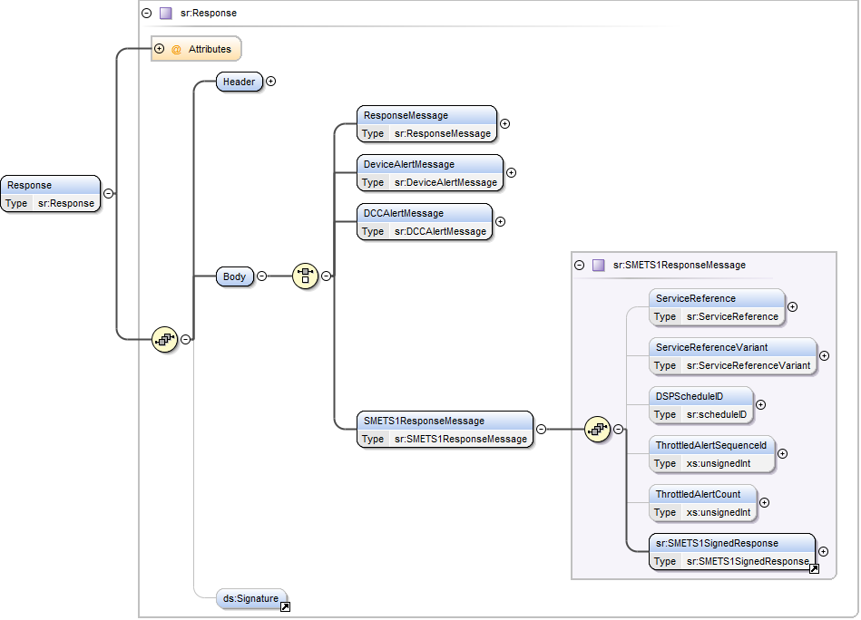

Amend Table 4 in Section 1.4.11.2 ‘SMETS1ResponseMessage Format’ as follows:
Data Item | Description | Type | Mandatory | Valid Values
ServiceReference | Identifier that signals the particular Service Reference to DCC (and is driven from the User’s selection of Request) | sr:ServiceReference  (See Error! Reference source not found.) | Yes | As per the Request
ServiceReferenceVariant | Identifier that signals the particular Service Reference Variant to DCC (and is driven from the User’s selection of Request) | sr:ServiceReferenceVariant  (See Error! Reference source not found.) | Yes | As per the Request
DSPScheduleID | Schedule ID generated by the DCC Systems  Valid Set: >= 0 and <= 1000000000000 | sr:scheduleID  (Restriction of xs:nonNegativeInteger) | Present for DCC Scheduled requests | See description
ThrottledAlertSequenceId | An optional data item that identifies that this Alert Code is currently subject to throttling by the DCC Data Systems.  If this attribute is included in the Alert then it indicates the sequence number for this Alert message since Alert throttling began. | xs:unsignedInt | No | As per Table 43
ThrottledAlertCount | An optional data item used to indicate the number of Alerts that have been consolidated by DCC Data Systems since the last Alert was forwarded to the Service User. | xs:unsignedInt | No | As per Table 43
SMETS1SignedResponse | Message created and signed by the S1SP. It contains a SMETS1 Response or a SMETS1 Alert | sr:SMETS1SignedResponse  (see clause Error! Reference source not found.) | Yes | See description

Amend the Figure 15 illustrated diagram Section 3.6.2 ‘Device Alerts - DeviceAlertMessage Format’ as follows:

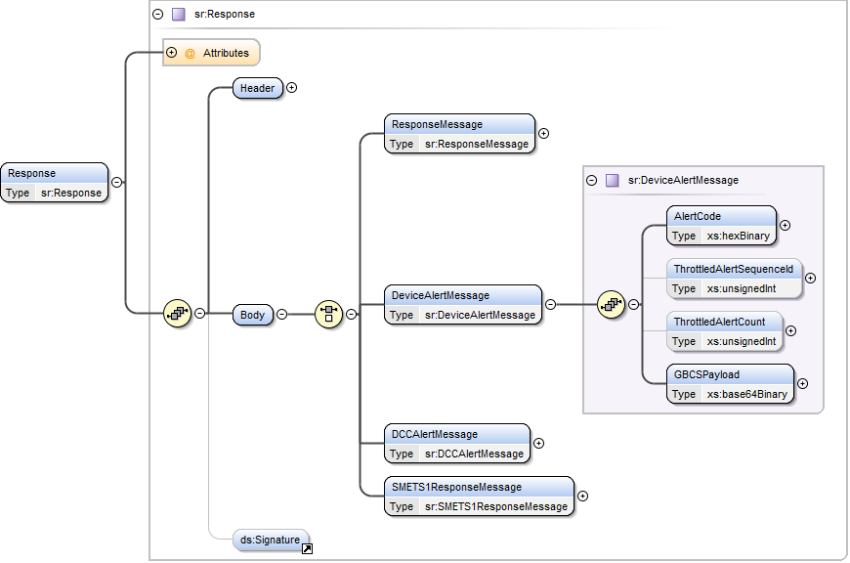

Amend Table 38 in Section 3.6.2.2 ‘Device Alerts Body Format’ as follows:
Data Item | Description | Type | Mandatory | Valid Values
AlertCode | Code indicating the alert or reason for the alert to be generated  GBCS includes ‘0x’ at the start of such codes. This definition uses a hexBinary representation for valid values. | xs:hexBinary | Yes | See GB Companion Specification for base list and apply hexBinary representation of these GBCS defined values
ThrottledAlertSequenceId | An optional data item that identifies that this Alert Code is currently subject to throttling by the DCC Data Systems.  If this attribute is included in the Alert then it indicates the sequence number for this Alert message since Alert throttling began. | xs:unsignedInt | No | As per Table 43
ThrottledAlertCount | An optional data item used to indicate the number of Alerts that have been consolidated by DCC Data Systems since the last Alert was forwarded to the Service User. | xs:unsignedInt | No | As per Table 43
GBCS Payload | See GB Companion Specification for Details of the format of the GBCS Alert | xs:base64Binary | Yes | See GB Companion Specification for message construction.

Amend the Figure 16 illustrated diagram in Section 3.6.3 ‘Device Alerts - DCCAlertMessage Format’ to the following:

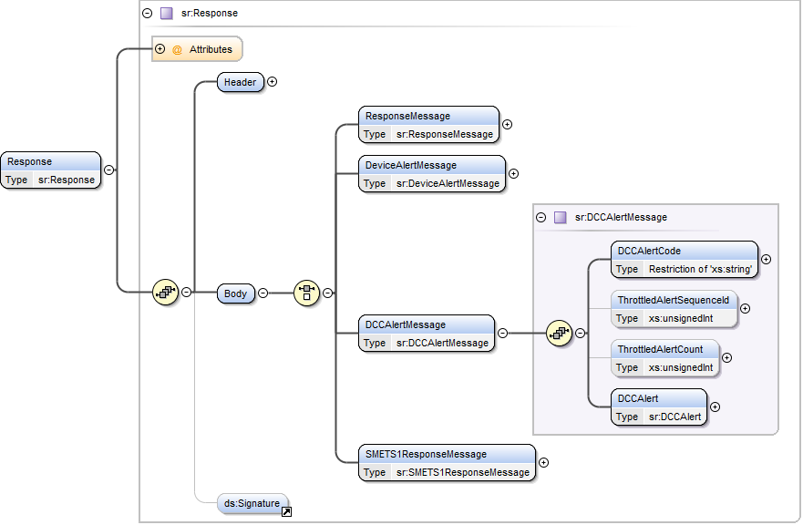

Amend Table 40 in Section 3.6.3.2 ‘DCC Alerts Body Format’ as follows:
Data Item | Description | Type | Mandatory | Valid Values
DCCAlertCode | Code indicating the alert or reason for the Alert to be generated by DCC | Restriction of xs:string (Enumeration) | Yes | See clause 3.6.3.4
DCCAlert | This is body specific content dependent on the DCCAlertCode being sent. See clause Error! Reference source not found. for body specific format. | sr:DCCAlert  See clause 3.9 | Yes | See clause 3.9
ThrottledAlertSeqeunceID | An optional data item that identifies that this Alert Code is currently subject to throttling by the DCC Data Systems.  If this attribute is included in the Alert then it indicates the sequence number for this Alert message since Alert throttling began. | xs:unsignedInt | No | As per Table 43
ThrottledAlertCount | An optional data item used to indicate the number of Alerts that have been consolidated by DCC Data Systems since the last Alert was forwarded to the Service User. | xs:unsignedInt | No | As per Table 43

Amend Annex A – DUIS XML SCHEMA with the following code entries to incorporate the ThrottledAlertSequenceID and ThrottledAlertCount functions to correspond with Figures 15 and 16 above:
<xs:complexType name="DeviceAlertMessage">
<xs:sequence>
<xs:element name="AlertCode" type="xs:hexBinary"> </xs:element>
<xs:element name="ThrottledAlertSequenceId" type="xs:unsignedInt" minOccurs="0" maxOccurs="1"/>
<xs:element name="ThrottledAlertCount" type="xs:unsignedInt" minOccurs="0" maxOccurs="1"/>

<xs:element name="GBCSPayload" type="xs:base64Binary" minOccurs="1" maxOccurs="1"/>
</xs:sequence>
</xs:complexType>

<xs:complexType name="DCCAlertMessage">
<xs:sequence>
<xs:element name="DCCAlertCode">
<xs:simpleType>
<xs:restriction base="xs:string">
<xs:enumeration value="AD1"/>
<xs:enumeration value="N1"/>
<xs:enumeration value="N2"/>
<xs:enumeration value="N3"/>
<xs:enumeration value="N4"/>
<xs:enumeration value="N5"/>
<xs:enumeration value="N6"/>
<xs:enumeration value="N7"/>
<xs:enumeration value="N8"/>
<xs:enumeration value="N9"/>
<xs:enumeration value="N10"/>
<xs:enumeration value="N11"/>
<xs:enumeration value="N12"/>
<xs:enumeration value="N13"/>
<xs:enumeration value="N14"/>
<xs:enumeration value="N15"/>
<xs:enumeration value="N16"/>
<xs:enumeration value="N17"/>
<xs:enumeration value="N18"/>
<xs:enumeration value="N19"/>
<xs:enumeration value="N20"/>
<xs:enumeration value="N21"/>
<xs:enumeration value="N22"/>
<xs:enumeration value="N23"/>
<xs:enumeration value="N24"/>
<xs:enumeration value="N25"/>
<xs:enumeration value="N26"/>
<xs:enumeration value="N27"/>
<xs:enumeration value="N28"/>
<xs:enumeration value="N29"/>
<xs:enumeration value="N30"/>
<xs:enumeration value="N31"/>
<xs:enumeration value="N33"/>
<xs:enumeration value="N34"/>
<xs:enumeration value="N35"/>
<xs:enumeration value="N36"/>
<xs:enumeration value="N37"/>
<xs:enumeration value="N38"/>
<xs:enumeration value="N39"/>
<xs:enumeration value="N40"/>
<xs:enumeration value="N41"/>
<xs:enumeration value="N42"/>
<xs:enumeration value="N43"/>
<xs:enumeration value="N44"/>
<xs:enumeration value="N45"/>
<xs:enumeration value="N46"/>
<xs:enumeration value="N47"/>
<xs:enumeration value="N48"/>
<xs:enumeration value="N49"/>
<xs:enumeration value="N50"/>
<xs:enumeration value="N51"/>
<xs:enumeration value="N52"/>
<xs:enumeration value="N53"/>
<xs:enumeration value="N54"/>
<xs:enumeration value="N55"/>
<xs:enumeration value="N56"/>
<xs:enumeration value="N57"/>
<xs:enumeration value="N58"/>
<xs:enumeration value="N999"/>
</xs:restriction>
</xs:simpleType>
</xs:element>
<xs:element name="ThrottledAlertSequenceId" type="xs:unsignedInt" minOccurs="0" maxOccurs="1"/>
<xs:element name="ThrottledAlertCount" type="xs:unsignedInt" minOccurs="0" maxOccurs="1"/>
<xs:element name="DCCAlert" type="sr:DCCAlert"/>
</xs:sequence>
</xs:complexType>

SECMP0067 Service Request Traffic Management (proposal is not YET approved)

Section 2.7 HTTP Response Codes, New HTTP response Code 429 added
429 | Too Many Requests – Indicates that Service Request Traffic Management is in operation, the User has sent too many requests and this request is being rejected.

Section 2.10 Error Handling, Table 8: General error handling updated to add New error scenario for “Too Many Service Requests”
Too Many Service Requests | When the volume of Service Requests into the DCC System exceeds the system capacity, then the Service Request Traffic Management system will reject non-Priority Service Requests from a User that is exceeding their capacity allocation.  Under these circumstances the DCC System shall respond with an HTTP Response Code of 429 – Too Many Requests.  The User system shall reduce their request submission rate and re-attempt the failed Service Requests after at least the delay period indicated in the RETRY-AFTER field of the HTTP response.

No Schema change is required

SECMP0081 Alignment of DUIS and CHISM to reflect current DCC Processing

Changes to Service Request 1.1.1 - Unit error correction for SMETS2 only
For SMETS2, section 3.8.1.2, table 59 GasThresholdMatrix (sr:GasThresholdMatrix), the units of the data item BlockThreshold corrected.
Data Item | Description / Allowable values | Type | Mandatory | Default | Units
BlockThreshold | Threshold between one block and the next. Up to 3 can be defined to match the corresponding prices. | sr:GasThresholdType  minOccurs = 1  maxOccurs = 3  (xs:unsignedLong) | Yes | None | Wh
index (Attribute of BlockThreshold) | Provides an ordering for the BlockThreshold elements.  Unique and consecutive numbers starting at 1. | sr:range_1_3  (xs:positiveInteger from 1 to 3) | Yes | None | N/A

For SMETS1, section 1.4.7.1 Update Tariff (Primary Element) SRV 1.1.1, updated to maintain the units of the data item BlockThreshold as kWh.

This clause is a supplement to clause Error! Reference source not found..
In relation to the GasThresholdMatrix element for SMETS1 Service Requests, the units for BlockThreshold data item in table 59 should be kWh instead of Wh.

The requirements of clause 1.4.7.2 shall additionally apply.

Note to Service User: Different unit are used between SMETS1 and SMETS2, this means Service Users back end system must have different process to build the service request.

Changes to Service Request 6.24.2
Adding a new section for Additional DCC System Processing for Device Certificate tracking.

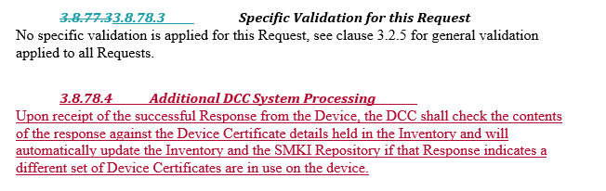

Changes to Service Request 8.13
Table in section 3.8.117.2 Specific Data Items for this Request updated to include addition 2 Service Requests.
Service Request Responses
3.2 - Restrict Access For Change Of Tenancy
6.8 - Update Device Configuration (Billing Calendar)
6.15.1 – Update Security Credentials (KRP)
6.14.1 - Update Device Configuration (Auxiliary Load Control Description)
6.14.2 - Update Device Configuration (Auxiliary Load Control Scheduler)
6.14.3 - Update Device Configuration (Auxiliary Controller Scheduler)
6.15.2 - Update Security Credentials (Device)
6.21 - Request Handover of DCC Controlled Device
6.23 - Update Security Credentials (CoS)
8.7.1 - Join Service (Critical)
8.7.2 - Join Service (Non-Critical)
8.8.1 - Unjoin Service (Critical)
8.8.2 - Unjoin Service (Non-Critical)
8.11 – Update HAN Device Log
8.12.1 - Restore HAN Device Log
8.12.2 - Restore Gas Proxy Function Device Log
11.2 – Read Firmware Version
11.3 - Activate Firmware

Changes to Service Request 8.14.2
Table in the section 3.8.118.3 updated as below
Response Code | Response Code Description
E081401 | The Device Type of the Device being notified is not CHF
E081402 | The install date & time supplied is a future date
W081401 | The CHF Device status is not ‘InstalledNotCommissioned’, which is the only valid status compatible with this Service Request.  Note: Status of the Device for the CHF and the associated GPF will be updated to InstalledNotCommissioned if it is still in the Pending State.

Adding a new section for Additional DCC System Processing for CHF device status is ‘Pending’ state.

3.8.119.4 Additional DCC System Processing
Where the CHF Device status is ‘Pending’ and response code W081401 is returned, the DCC shall update the CHF Device status to ‘InstalledNotCommissioned’. If the GPF Device status is also ‘Pending’ the DCC shall update the GPF Device status to ‘InstalledNotCommissioned’.

SECMP093 Implementing IRP511 and CRP535 to support GBCS v3.2 devices (proposal is not YET approved)

Changes to Service Request 8.9

Section 3.8.113.1 Service Description
Service Request Name | - ReadDeviceLog
Service Reference | - 8.9
Service Reference Variant | - 8.9
Eligible Users | Import Supplier (IS)  Gas Supplier (GS)  Other User (OU)
Security Classification | Non Critical
BusinessTargetID  - Device Type applicable to this request | Electricity Smart Meter (ESME)  Gas Smart Meter (GSME)  Gas Proxy Function (GPF)  Communications Hub Function (CHF)  HAN Connected Auxiliary Load Control Switch (HCALCS)  PrePayment Interface Device (PPMID)
Can be future dated? | DSP
On Demand? | Yes
Capable of being DCC Scheduled? | No
Command Variants applicable to this Request  (Only one populated) | 1 – Send (Non-Critical)  2 – Return for local delivery (Non-Critical)  3 – Send and Return for local delivery (Non-Critical)
Common Header Data Items | See clause Error! Reference source not found.
Data Items Specific to this Service Request | See Specific Data Items Below
Possible responses from this Service Request | These are the possible responses applicable to this Service Request. Please see clause Error! Reference source not found. for more details on processing patterns  Also see Response Section below for details specific to this request
Response Codes possible from this Service Request | See clause Error! Reference source not found. for Common Response Codes
GBCS Cross Reference | Communications Hub Function | All Other Devices
GBCS v1.0 MessageCode | 0x0004 | 0x0013
GBCS v1.0 Use Case | CCS05/CCS04 | CS07
GBCS v2.0 MessageCode | 0x010F | 0x0013
GBCS v2.0 Use Case | CCS06 | CS07
GBCS Commands - Versioning Details
DCC System creates the following GBCS Commands or Response Codes based on the following combinations,
Device Type | CHF
GBCS version that pertains to the Device Model recorded in the SMI for the Business Target Device ID specified in the Service Request | GBCS v1.0 | GBCS v2.0 |  | GBCS v3.2
DEFAULT - No specific XML criteria | CCS05/CCS04 | CCS06 |  | CCS06
XML Criteria - XML data item ReadSecurityDetails included | E080902 | E080902 |  | CCS07
Device Type | ESME
GBCS version that pertains to the Device Model recorded in the SMI for the Business Target Device ID specified in the Service Request | GBCS v1.0 |  | GBCS v2.0
DEFAULT - No specific XML criteria | CS07 |  | CS07
Device Type | GSME
GBCS version that pertains to the Device Model recorded in the SMI for the Business Target Device ID specified in the Service Request | GBCS v1.0 |  | GBCS v2.0
DEFAULT - No specific XML criteria | CS07 |  | CS07
Device Type | GPF
GBCS version that pertains to the Device Model recorded in the SMI for the Business Target Device ID specified in the Service Request | GBCS v1.0 |  | GBCS v2.0
DEFAULT - No specific XML criteria | CS07 |  | CS07
Device Type | HCALCS
GBCS version that pertains to the Device Model recorded in the SMI for the Business Target Device ID specified in the Service Request | GBCS v1.0 |  | GBCS v2.0
DEFAULT - No specific XML criteria | CS07 |  | CS07
Device Type | PPMID
GBCS version that pertains to the Device Model recorded in the SMI for the Business Target Device ID specified in the Service Request | GBCS v1.0 |  | GBCS v2.0
DEFAULT - No specific XML criteria | CS07 |  | CS07

Section 3.8.113.2 Specific Data Items for this Request
ReadDeviceLog Definition
Data Item | Description / Values | Type | Mandatory | Default | Units
ExecutionDateTime | A User shall only add this Data Item to the Service Request where they require the Service Request to be executed at a future date and time.  The UTC date and time the User requires the command to be executed on the Device  - Date-time in the future that is either <= current date + 30 days or the date = ‘3000-12-31T00:00:00Z’ | xs:dateTime | No | None | UTC Date-Time
ReadSecurityDetails | This parameter is supplied if the User wishes to the CHF Device Log and the CHF Historic Device Log. | sr: ReadSecurityDetails | No | None | None
Table 1 : ReadDeviceLog (sr:ReadDeviceLog) data items

Update Section 3.8.113.3 Specific Validation for this Request
See clause 3.2.5 for general validation applied to all Requests and clause 3.10.2 for Execution Date Time validation.
Response Code | Response Code Description
E080902 | The GBCS version that pertains to the Device Model recorded in the SMI for this Device, does not support the chosen features of this Service Request.
E080903 | The Device Type is not a CHF however ‘ReadSecurityDetails’ is specified in the Service Request.

SMETS1 – BEIS directive - changes

CR1290 - Re-scaling of Gas Flow rate in SRV to match SMETS2

Section 1.4.6 Additional or Alternative Validation Conditions for SMETS1 Service Requests, table 2 updated for E060701
6.7 | E060701 | Amended condition for SMETS1 Devices | Check if the target Device is a SMETS1 GSME according to the Smart Metering Inventory, the associated S1SP supports the XML element named UncontrolledGasFlowRateDecimal

Section 1.4.7.10 Update Device Configuration SRV 6.7 updated

Defect Fix

CR1277: SMETS 1 SEV 2 DESIGN FIX on DUIS: Install Code Length, 2nd part to put back the validation for SMETS2
For the first part of the defect fix
Briefed at May, June and July 2019 Design Release Forum (DRF), A small consequential change made to DUIS v3.1 to address a design fix made to DUIS V3.0 which allow the shorter install code for both SMETS1 and SMETS2 via schema change.

Second part of the defect fix
Briefed at Feb and March 2020 DRF, A small consequential change included in DUIS v4.0
- A new validation check is introduced to verify that the length of install code is 16 octets for the SMETS2 Devices.
- If the check fails, the Service Request will be rejected using the error code E081111.
E081111 | The Service Request refers to a SMETS2 Device but the InstallCode field is not 32 characters (representing 16 octets) in length.

DUIS inconsistency for GCS01a
Briefed at March 2020 DRF,
- During the DUIS review, an inconsistency is discovered for SR1.1.1 for GCS01a between the Schema and the document
- DUIS document:
in Table 59: GasThresholdMatrix, that the type of BlockThreshold (sr:GasThresholdType) is xs:unsignedLong. The maximum value for this type (xs:unsignedLong) is 18,446,744,073,709,551,615.
- DUGIDS document: align with DUIS
- DUIS schema:
for this same type (sr:GasThresholdType), a MA Inclusive value of 281,474,976,710,656.
- GBCS:
According to GBCS, the maximum value for Gas Thresholds is an Unsigned 48-bit Integer (0xFFFFFFFFFFFF = 281,474,976,710,655).

- Fixed the schema and DUIS to align with GBCS

Data Item | Description / Allowable values | Type | Mandatory | Default | Units
BlockThreshold | Threshold between one block and the next. Up to 3 can be defined to match the corresponding prices. | sr:GasThresholdType  minOccurs = 1  maxOccurs = 3  (xs:unsignedLong)  (maxInclusive = 281474976710655) | Yes | None | Wh
Index (Attribute of BlockThreshold) | Provides an ordering for the BlockThreshold elements.  Unique and consecutive numbers starting at 1. | sr:range_1_3  (xs:positiveInteger from 1 to 3) | Yes | None | N/A
Table 2 : GasThresholdMatrix (sr:GasThresholdMatrix) data items

BEIS directive – SMETS2 – Auxiliary Proportional Control

New ESME variants
A SMETS2+ ESME complies with SMETS2 section 5 or section 9. In other word, an SAPC is a variant of ESME.
- Table 41 updated for N43
- For SR6.13 Read Event Or Security Log, Table 177 updated for LogToRead data item
- For SR8.2 read inventory, Table 227, data Item “ESMEVariant” updated to including F and G
- For SR8.2 read inventory, Table 229 updated to including F and G
- For SR8.4 Update inventory, Table 232, data Item “ESMEVariant” updated to including F and G
- For SR12.2 Device Pre-notification, Table 261, data Item “ESMEVariant” updated to including F and G
- For N16 alert, Table 3 : MeterIdentity (sr:MeterIdentity) data items “ESMEVariant” updated to including F and G
- For N58 alert, Table 297a ALCSHCALCSConfigurationchange updated to including 2 additional optional data Item “ESMEVariant” and “DeviceGBCSVersion”

New Service Request
- Table 18 updated to add 5 new Service Request
Update Device Configuration (Auxiliary Controller Scheduler) | 6.14 | 6.14.3 | Yes | Yes | Device | No | No | IS | No
Set Auxiliary Controller State | 7.13 | 7.13 | Yes | Yes | No | No | No | IS | No
Read Auxiliary Controller Configuration Data | 7.14 | 7.14 | No | Yes | DSP | No | No | IS  ED  OU | No
Read Auxiliary Controller Operational Data | 7.15 | 7.15 | No | Yes | DSP | No | No | IS  ED  OU | No
Limit APC Level | 7.16 | 7.16 | Yes | Yes | No | No | No | None | No

- New Section 3.8.66 , SR6.14.3 Update Device Configuration (Auxiliary Controller Scheduler)added
- New Section 3.8.99 , SR7.13 Set Auxiliary Controller State added
- New Section 3.8.100 , SR7.14 Read Auxiliary Controller Configuration Data added
- New Section 3.8.101 , SR7.15 Read Auxiliary Controller Operational Data added
- New Section 3.8.102 , SR7.16 Limit APC Level added

Updated Service Request
- Section 3.8.64, SR6.14.1 Update Device Configuration (Auxiliary Load Control Description) , SwitchDescription length change from 127 to 22
- Section 3.8.67, SR6.15.1 UpdateSecurityCredentials(KRP) , supporting new GBCS use case

Service Request updated due to deprecated Use Case in GBCS4.0
- Section 3.8.65, SR6.14.2 UpdateDeviceConfiguration(AuxiliaryLoadControlScheduler) CS02g for update the certificate in the LoadController trust anchor cell
- Section 3.8.77, SR6.24.1 RetrieveDeviceSecurityCredentials(KRP) CS02a targeting ESME
- Section 3.8.91, SR7.5 ActivateAuxiliaryLoad ECS47
- Section 3.8.92, SR7.6 DeactivateAuxiliaryLoad ECS47
- Section 3.8.93, SR7.7 ReadAuxiliaryLoadSwitchData, ECS61a
- Section 3.8.94, SR7.8 ResetAuxiliaryLoad, ECS47

Table 41 updated for N58
N58 | ALCS/HCALCS configuration change | ALCS/HCALCS configuration changed on ESME | Upon successful completion of Service Request 6.14.2 Update Device Configuration (Auxilliary Load Control Scheduler)  OR  Upon successful completion of Service Request 6.14.1 Update Device Configuration (Auxilliary Load Control Descriptions)  OR  Upon successful completion of Service Request 6.14.3 Update Device Configuration (Auxiliary Controller Scheduler)  OR  Future Dated Execution Of Instruction Alert (DLMS COSEM) Alert (Alert Code 0x8F66 and Message Code 0x00CC) corresponding to AuxiliaryLoadControlSwitchesCalendar received by the DCC Data Systems | ED | SMETS2+

Managing the new Load Controller trust anchor cells

- Section 3.8.67 for SR 6.15.1 UpdateSecurityCredentials(KRP),
  - supporting new use case CS02g for update the certificate in the LoadController trust anchor cell
  - Table 184 , description of the data item “RemotePartyRole” updated to including new role of “LoadController”
  - Table 184 , description of the data item “RemotePartyFloorSeqNumber” updated so that “LoadController” will has same behaviour as supplier (unlike NetworkOperator)
  - Table 185 , description of the data item “SupplierOrNetworkOperatorCertificates” updated so support “Load Controller”
  - Error validation and code “E061509” added
- Section 3.8.77, for SR6.24.1 Retrieve Device Security Credentials (KRP)
  - Service Description updated for supporting new use case CS02f targeting ESME
  - Table 207, description of the data item “RemotePartyRole” updated to including new role of “LoadController”
  - Error validation and code “E062402” and “E062403” added

Changes (Documentation-only) due to GBCS use case names changes
Following Service Requests had documentation only change. This applies where there is no change to the GBCS command or message code, but the GBCS use case names have changed
- Section 3.8.14, SR3.3 Clear Event Log;
- Section 3.8.63, SR6.13 ReadEventOrSecurityLog
- Section 3.8.95, SR 7.9 Add Auxiliary Load To Boost Button
- Section 3.8.96, SR 7.10 Remove Auxiliary Load From Boost Button
- Table 262, DCCAlert (sr:DCCAlert) data items

GBCS Cross reference and compability, Moving to GBCS4
- All previous mentioned “GBCS v3.2”, needs now state “GBCS v3.2 or later”, this change applies to
  - Section 3.8.59, SR6.7 UpdateDeviceConfiguration(GasFlow)
  - Section 3.8.63, SR6.13 ReadEventOrSecurityLog
  - Section 3.8.113, SR8.9 ReadDeviceLog
- New functions introduced in GBCS 4.0, e.g. change the wording to either “ GBCS version earlier than v4.0” or “GBCS v4.0 or later”
  - Section 3.8.65, SR6.14.2 UpdateDeviceConfiguration(AuxiliaryLoadControlScheduler)
  - Section 3.8.7 updated for SR 6.15.1 UpdateSecurityCredentials(KRP),
  - Section 6.24.1 updated for SR6.24.1 RetrieveDeviceSecurityCredentials(KRP)
  - Section 3.8.91 updated for SR7.5 ActivateAuxiliaryLoad, deprecated in GBCS v4.0
  - Section 3.8.92 updated for SR7.6 DeactivateAuxiliaryLoad, deprecated in GBCS v4.0
  - Section 3.8.93 updated for SR7.7 ReadAuxiliaryLoadSwitchData, deprecated in GBCS v4.0
  - Section 3.8.94 updated for SR7.8 ResetAuxiliaryLoad, deprecated in GBCS v4.0

Clarification and error highlighted during the review of DUIS4.0 change related to CRP612

Adding missing/new terms into section 1.3 Defined Terms
- ALCS
- APC
- Auxiliary Controller Event Log
- CHF Device Log
- CHF Historic Device Log
- Electricity Smart Meter
- ESME
- Load Controller
- Network Operator
- SAPC

Ensure Table 105 and Table 102 are consistent for DaysOfWeekApplicability
Table 102
DaysOfWeekApplicability | The days of the week to which the schedule applies defined as an array of up to 7 DayOfWeekIDs | sr:DaysOfWeekApplicability  See Error! Reference source not found. | Yes  Minimum of 0 and maximum of 7 Days Of Week Applicability.  If there are no applicable Days, this XML element will be present, but empty, i.e. it will contain 0 DayOfWeekApplicability elements | None | N/A

Table 105
DaysOfWeekApplicability | Array of Day Of Week IDs  This indicates the days on which the schedule is active.  Unique and chronologically ordered, may not be consecutive. | sr:DaysOfWeekApplicability  See Error! Reference source not found. | Yes  sr:DayOfWeekApplicability  (minOccurs = 0, maxOccurs = 7)  If there are no applicable Days, this XML element will be present, but empty, i.e. it will contain 0 DayOfWeekApplicability elements | None | N/A

Table 41 updated for N18/N19/N20/N21 to clarify DCC system behaviour
N18 | Firmware Version / Hash mismatch | Firmware Version / Hash mismatch | Firmware Hash calculated by CSP or S1SP doesn’t match Firmware Version | Update Firmware request sender | All
N19 | Firmware Distribution Device ID identification failure | Firmware Distribution Device ID identification failure | CSP or S1SP unable to identify Communications Hub or Meter Device Id a Firmware Image is to be sent to | Update Firmware request sender | All
N20 | Firmware image provided is too large | Firmware image provided is too large | CSP or S1SP unable to process request, because the Firmware Image is too large | Update Firmware request sender | All
N21 | Unknown Firmware Version | Unknown Firmware Version | CSP or S1SP unable to process request, because it doesn’t recognise the Firmware Version | Update Firmware request sender | All

Clarify the AD1 Power Outage Event
AD1 | Power Outage Event | Power Outage Event received from CSP | Communications Service Provider (CSP) notification of loss of DC power as detected at the Communications Hub in the Consumer Premises for a time equal to or greater than three (3) minutes | IS  ED  (User ID with User Role IS / ED for an Electricity Smart Meter associated with the Communications Hub Function reporting the Power Outage)  GS  GT  (User ID with User Role GS / GT for a Gas Smart Meter associated to the Communications Hub Function reporting the Power Outage) | SMETS2+

SCHEMA changes
Embedded HTML shows all the schema change since version 3.1.
All BEIS directive changes are marked up in yellow.

Known future documentation changes

CR1045 - extending the existing firmware update process to SMETS1 PPMID devices (BEIS directive)

SRV11.1 Update Firmware
- W110101 validation: allow SMETS1 PPMID and continuing to reject SMETS2 PPMIDs;
- N57 to the gas supplier for dual fuel SMETS1 Installations.

Table 2 updated:
11.1 | W110101 | Amended condition for SMETS1 Devices | Invalid conditions listed in this Update Firmware warning may relate to a SMETS1 CH or PPMID as well as a Smart Meter.  An additional condition for listing a SMETS1 CH or PPMID in the InvalidDeviceIDList is where the DCC User submitting the Update Firmware Service Request is not the Lead Supplier for the SMETS1 CH.

Section 1.4.7.13 updated
SRV 11.1 shall be supported for SMETS1 CHs and PPMIDs as well as SMETS1 Smart Meters.

Following the receipt by DCC of a successfully authenticated Update Firmware Service Request to distribute firmware to a SMETS1 CH or PPMID, if there is a GSME associated with the SMETS1 CHF, on the same home area network, in the Smart Metering Inventory then the DCC shall issue DCC Alert with code N57 to inform the Gas Supplier of the Service Request.

Section 3.6.3.4 Table 41, N57 updated
N57 | SMETS1 CH or PPMID Firmware notification | See clauses 0 and Error! Reference source not found.. | See clauses 0 and Error! Reference source not found.. | Gas Supplier associated with the SMETS1 CHF or PPMID | SMETS1

SRV 11.2 Read Firmware
- E11 validation: allow SMETS1 PPMID and continuing to reject SMETS2 PPMIDs;
- Behaviour regarding DCC Alerts and updating of firmware version information in the inventory will follow the pattern used for ESME:
- The inventory will be updated if a CPL-compliant firmware version is returned in the response that is different to the inventory entry;

New Section 1.4.7.16 added for SRV11.2
1.4.7.14 Read Firmware Version SRV 11.2
This clause is a supplement to clause 3.8.124.

SRV 11.2 shall be supported for SMETS1 PPMIDs as well as SMETS1 CHs and Smart Meters.

All except the last points in clause 3.8.124.4 shall also apply where the targets Device is a SMETS1 PPMID.

Table 41 updated for N49,N50,N51
N49 | Firmware Version Updated in the Smart Metering Inventory | Device’s Firmware Version updated in the Smart Metering Inventory | Upon successful completion of Service Request 11.2 Read Firmware Version where the target Device is ESME, GSME , CHF or SMETS1 PPMID and the Firmware Version returned by the Device is different from that in the SMI and it matches an entry on the CPL with a status of “Current” | IS  GS  (Only sent if the IS / GS did not submit the Service Request) | All
N50 | Firmware Version no longer valid on the CPL | Device’s Firmware Version updated in the Smart Metering Inventory, but Device Status not set to ‘Suspended’ | Upon successful completion of Service Request 11.2 Read Firmware Version where the target Device is ESME, GSME, CHF or SMETS1 PPMID and the Firmware Version returned by the Device is different from that in the SMI and it matches an entry on the CPL with a status of “Removed”  OR  Upon successful completion of Service Request 11.3 Activate Firmware where the Firmware Version returned by the Device is different from that in the SMI and it matches an entry on the CPL with a status of “Removed”  OR  Future Dated Firmware Activation Alert (Alert Code 0x8F66 and Message Code 0x00CA) received by the DCC Systems where the Firmware Version returned by the Device is different from that in the SMI and it matches an entry on the CPL with a status of “Removed” | IS  GS | All
N51 | Invalid Firmware Version | Device’s Firmware Version is unknown (not in the CPL)  Device’s Firmware Version not updated in the Smart Metering Inventory | Upon successful completion of Service Request 11.2 Read Firmware Version where the target Device is ESME, GSME, CHF or SMETS1 PPMID and the Firmware Version returned by the Device is different from that in the SMI and it doesn’t match an entry on the CPL  OR  Upon successful completion of Service Request 11.3 Activate Firmware where the Firmware Version returned by the Device is different from that in the SMI and it doesn’t match an entry on the CPL  OR  Future Dated Firmware Activation Alert (Alert Code 0x8F66 and Message Code 0x00CA) received by the DCC Systems where the Firmware Version returned by the Device is different from that in the SMI and it doesn’t match an entry on the CPL | IS  GS | All

SRV11.3 Activate Firmware
- E11 validation: allow SMETS1 PPMID and continuing to reject SMETS2 PPMIDs;
- Extend behaviour regarding suspended firmware versions and DCC Alerts N29, N50 and N51 to SMETS1 PPMIDs, as indicated in DUIS for SMETS2 devices;
- If the firmware has been successfully updated then DCC Alert N57 will be sent in the same circumstances as for SRV 11.1.

Section 1.4.7.14 updated

SRV 11.3 shall be supported for SMETS1 CHFs and PPMIDs as well as SMETS1 Smart Meters.

Where the DCC produces a SMETS1 Response indicating successful activation of SMETS1 CH or PPMID firmware, if there is a GSME associated with the SMETS1 CHF comprising that SMETS1 CHF in the Smart Metering Inventory then the DCC shall issue a DCC Alert with code N57 to inform the Responsible Gas Supplier of the activation.

Table 41 updated for N57 updated
N57 | SMETS1 CH or PPMID Firmware notification | See clauses 0 and Error! Reference source not found.. | See clauses 0 and Error! Reference source not found.. | Gas Supplier associated with the SMETS1 CHF or PPMID | SMETS1

Inconsistent Units between DUIS/MMC/GBCS and DCC system
Briefed at Feb 2020 DRF, and will progress the change via SECMOD

SMETS 1 CR1291, enable customer to perform DSP scheduled read for SR4.4.3

Appendix - Scope of the changes
Following items are included in the Spec Uplift for Nov 2020
Source | Item | DUIS Doc | DUIS Schema | MMC Doc | MMC Schema | Other Spec | DCC System Impacted
SECMOD | SECMP0062 -Traffic Management - Alert Storm Protection Part 2 | Y | Y | N | N | N | DSP
SECMOD | SECMP0067 -Service Request Traffic Management | Y | N | N | N | N | DSP
SECMOD | SECMP0081 - ‘Alignment of DUIS and CHISM to reflect current DCC Processing | Y | N | N | N | Y (S1SR) | Document Only
SECMOD | SECMP0093 -Implementing IRP511 and CRP535 to support GBCS v3.2 devices | Y | Y | Y | Y | N | DSP only  P&C
SECMOD | SECMP0098 -Incorporation of multiple Issue Resolution Proposals into the SEC - Batch 3 | N | N | N | N | Y (GBCS4, SMETS5, CHTS) | CH
BEIS SMETS2 | CRP612 Auxiliary Proportional Controllers (CR1145) | Y | Y | Y | Y | Y (GBCS4, SMETS5, CHTS) | DSP  P&C
BEIS SMETS1 | CR1045 extending the existing firmware update process to SMETS1 PPMID devices | Y | N | N | N | Y (S1SR) | DSP  S1SP  DCO
Defect Fix | CR1277 Completion of CR1164 Change to Install Code Length in 8.11 | Y | Y | N | N | N | DSP
SMETS1 Other | CR1290 Re-scaling of Gas Flow rate in SRV to match SMETS2 | Y | N | N | N | Y (S1SR) | DSP  S1SP  DCO

For customer information only, following items in the Nov 2020 SEC release scope, does not require any Spec Uplift
Source | Item | DUIS Doc | DUIS Schema | MMC Doc | MMC Schema | Other Spec | DCC System Impacted
BEIS SMETS2 | XMLSigning Remote Party Role | N | N | N | N | N | N

For customer information only, following items were previously communicated are NOT included in the Spec Uplift for Nov 2020, however are included in the future change section of the release note
Source | Item | DUIS Doc | DUIS Schema | MMC Doc | MMC Schema | Other Spec | DCC System Impacted
SMETS1 Other | CR1291 The ability of SMETS1 devices to be DSP scheduled for SRV4.4.3 | Y | Y | N | N | Y (S1SR) | DSP  S1SP  DCO
Document Defect | Inconsistent Units between DUIS/MMC/GBCS and DCC system | Y | N | Y | N | Y (S1SR) | DSP  S1SP  DCO

